**VISVESVARAYA TECHNOLOGICAL UNIVERSITY**

**“JnanaSangama”, Belgaum -590014, Karnataka.**



**LAB REPORT**

**on**

**Operating Systems**

**(22CS4PCOPS)**

***Submitted by:***

**Vanaja E(1BM24CS429)**

***in partial fulfillment for the award of the degree of***

**BACHELOR OF ENGINEERING**

***in***

**COMPUTER SCIENCE AND ENGINEERING**



**B.M.S. COLLEGE OF ENGINEERING**

**(Autonomous Institution under VTU)**

**BENGALURU-560019**

**June 2023 - August 2023**

**B. M. S. College of Engineering,**

**Bull Temple Road, Bangalore 560019**

(Affiliated To Visvesvaraya Technological University, Belgaum)

**Department of Computer Science and Engineering**



**CERTIFICATE**

This is to certify that the Lab work entitled “**Operating Systems**” carried out by **Vanaja E (1BM24CS429),** who is bonafide student of **B. M. S. College of Engineering.** It is in partial fulfillment for the award of **Bachelor of Engineering in Computer Science and Engineering** of the Visvesvaraya Technological University, Belgaum during the year 2022-23. The Lab report has been approved as it satisfies the academic requirements in respect of **Operating Systems - (22CS4PCOPS)** work prescribed for the said degree.

**Basavaraj Jakkalli**              **Megha J**

Associate Professor Assistant Professor

Department of CSE Department of CSE

BMSCE, Bengaluru BMSCE, Bengaluru

**Table Of Contents**

|  |  |  |
| --- | --- | --- |
| **Lab Program No.** | **Program Details** | **Page No.** |
| 1 | FCFS AND SJF | 3-6 |
| 2 | PRIORITY SCHEDULING | 6-12 |
| 3 | MULTI-LEVEL QUEUE SCHEDULING  RATE-MONOTONIC  EARLIEST-DEADLINE-FIRST | 13-16 |
| 4 | PRODUCER-CONSUMER PROBLEM  DINERS-PHILOSOPHERS PROBLEM | 17-23 |
| 5 | BANKERS ALGORITHM(DEADLOCK AVOIDANCE)  AND  DEADLOCK DETECTION | 24-26 |
| 6 | CONTIGIOUS MEMORY ALLOCATION  (FIRST, BEST, WORST FIT) | 26-29 |
| 7 | PAGE REPLACEMENT(FIFO, LRU, OPTIMAL) | 30-32 |

**Course Outcomes**

**CO1:** Apply the different concepts and functionalities of OS

**CO2:** Analyse various Operating system strategies and techniques.

**CO3:** Demonstrate the different functionalities of Operating System.

**CO4:** Conduct practical experiments to implement the functionalities of Operating system.

**Lab 1:**

**Write a C program to simulate the following non-pre-emptive CPU**

**scheduling algorithm to find turnaround time and waiting**

**time.**

1. **FCFS**

#include <stdio.h>

#define MAX 20

int n, i, j;

int Burst_time[MAX], Arrival_time[MAX], Waiting_time[MAX], Turn_around_time[MAX], Completion_time[MAX], process[MAX];

float avg_Turn_around_time = 0, avg_Waiting_time = 0;

void sortByArrival() {

for (i = 0; i < n - 1; i++) {

for (j = i + 1; j < n; j++) {

if (Arrival_time[i] > Arrival_time[j]) {

int temp = Arrival_time[i];

Arrival_time[i] = Arrival_time[j];

Arrival_time[j] = temp;

temp = Burst_time[i];

Burst_time[i] = Burst_time[j];

temp = process[i];

process[i] = process[j];

process[j] = temp;

}

}

}

}

void FCFS() {

sortByArrival();

Completion_time[0] = Arrival_time[0] + Burst_time[0];

Turn_around_time[0] = Completion_time[0] - Arrival_time[0];

Waiting_time[0] = Turn_around_time[0] - Burst_time[0];

for (i = 1; i < n; i++) {

if (Arrival_time[i] > Completion_time[i - 1]) {

Completion_time[i] = Arrival_time[i] + Burst_time[i];

} else {

Completion_time[i] = Completion_time[i - 1] + Burst_time[i];

}

Turn_around_time[i] = Completion_time[i] - Arrival_time[i];

Waiting_time[i] = Turn_around_time[i] - Burst_time[i];

}

printf("\nProcess\tArrival Time\tBurst Time\tWaiting Time\tTurnaround Time");

for (i = 0; i < n; i++) {

avg_Waiting_time += Waiting_time[i];

avg_Turn_around_time += Turn_around_time[i];

printf("\nP[%d]\t\t%d\t\t%d\t\t%d\t\t%d", process[i], Arrival_time[i], Burst_time[i], Waiting_time[i], Turn_around_time[i]);

}

avg_Waiting_time /= n;

avg_Turn_around_time /= n;

printf("\n\nAverage Waiting Time: %.2f", avg_Waiting_time);

printf("\nAverage Turnaround Time: %.2f\n", avg_Turn_around_time);

}

int main() {

printf("Enter the total number of processes: ");

scanf("%d", &n);

for (i = 0; i < n; i++) {

printf("\nEnter Arrival Time for P[%d]: ", i + 1);

scanf("%d", &Arrival_time[i]);

printf("Enter Burst Time for P[%d]: ", i + 1);

scanf("%d", &Burst_time[i]);

process[i] = i + 1;

}

FCFS();

return 0;

}

**Output:**

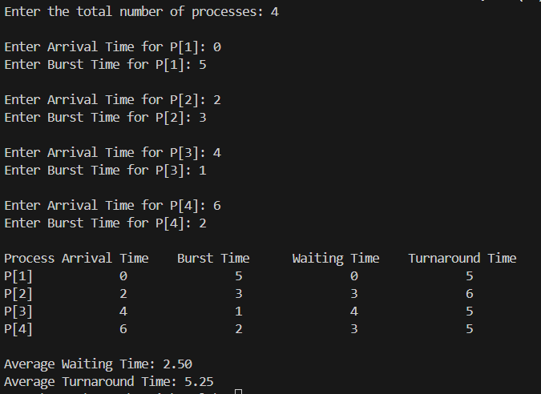

1. **SJF (pre-emptive & Non-preemptive)**

#include<stdio.h>

int n, i, j, pos, temp, Burst_time[20], Arrival_time[20], Waiting_time[20], Turn_around_time[20], Completion_time[20], process[20], total = 0;

float avg_Turn_around_time = 0, avg_Waiting_time = 0;

void sortByArrivalAndBurst() {

for (i = 0; i < n - 1; i++) {

for (j = i + 1; j < n; j++) {

if (Arrival_time[i] > Arrival_time[j] || (Arrival_time[i] == Arrival_time[j] && Burst_time[i] > Burst_time[j])) {

int temp_arrival = Arrival_time[i];

Arrival_time[i] = Arrival_time[j];

Arrival_time[j] = temp_arrival;

int temp_burst = Burst_time[i];

Burst_time[i] = Burst_time[j];

Burst_time[j] = temp_burst;

int temp_process = process[i];

process[i] = process[j];

process[j] = temp_process;

}

}

}

}

int SJF() {

sortByArrivalAndBurst();

Completion_time[0] = Arrival_time[0] + Burst_time[0];

Turn_around_time[0] = Completion_time[0] - Arrival_time[0];

Waiting_time[0] = Turn_around_time[0] - Burst_time[0];

for (i = 1; i < n; i++) {

if (Arrival_time[i] >= Completion_time[i - 1]) {

Completion_time[i] = Arrival_time[i] + Burst_time[i];

} else {

Completion_time[i] = Completion_time[i - 1] + Burst_time[i

}

Turn_around_time[i] = Completion_time[i] - Arrival_time[i];

Waiting_time[i] = Turn_around_time[i] - Burst_time[i];

}

avg_Waiting_time = 0;

total = 0;

printf("\nProcess\tArrival Time\tBurst Time\tWaiting Time\tTurnaround Time");

for (i = 0; i < n; i++) {

total += Turn_around_time[i];

avg_Waiting_time += Waiting_time[i];

printf("\nP[%d]\t%d\t\t%d\t\t%d\t\t%d", process[i], Arrival_time[i], Burst_time[i], Waiting_time[i], Turn_around_time[i]);

}

avg_Waiting_time /= n;

avg_Turn_around_time = (float)total / n;

printf("\n\nAverage Waiting Time=%.2f", avg_Waiting_time);

printf("\nAverage Turnaround Time=%.2f\n", avg_Turn_around_time);

return 0;

}

int main() {

printf("Enter the total number of processes: ");

scanf("%d", &n);

for (i = 0; i < n; i++) {

printf("Enter Arrival Time for P[%d]: ", i + 1);

scanf("%d", &Arrival_time[i]);

printf("Enter Burst Time for P[%d]: ", i + 1);

scanf("%d", &Burst_time[i]);

process[i] = i + 1;

}

SJF();

return 0;

}

**Output:**

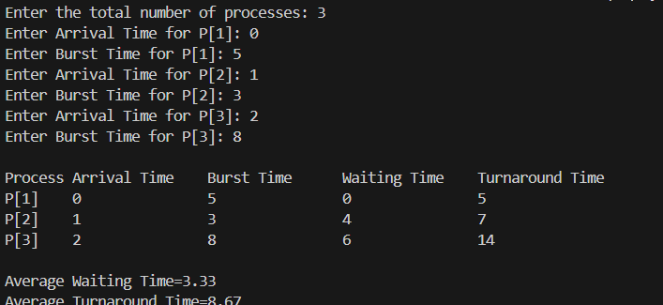

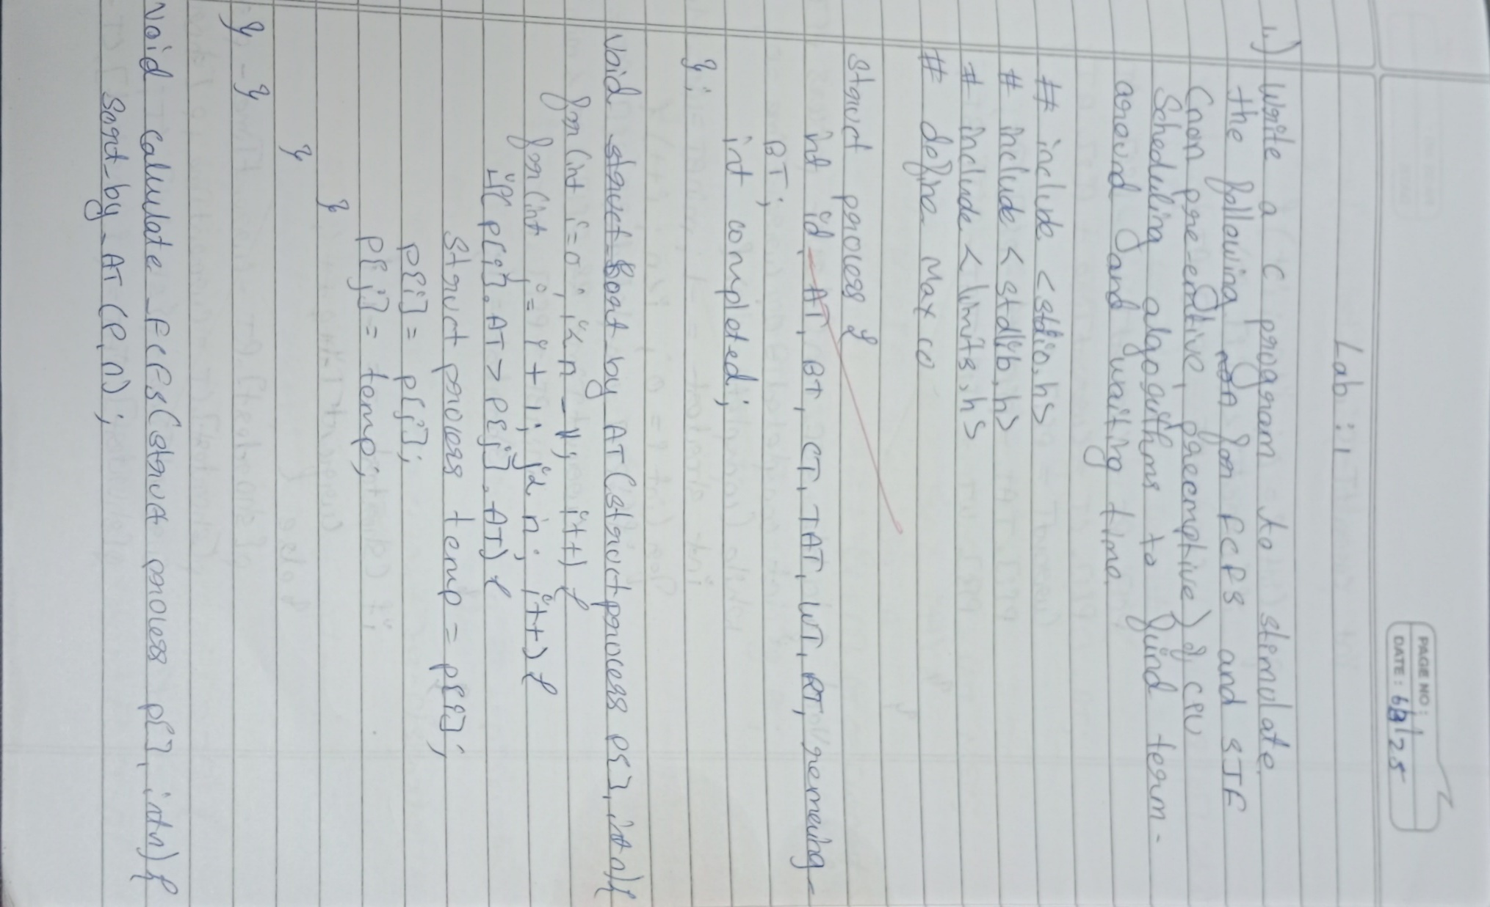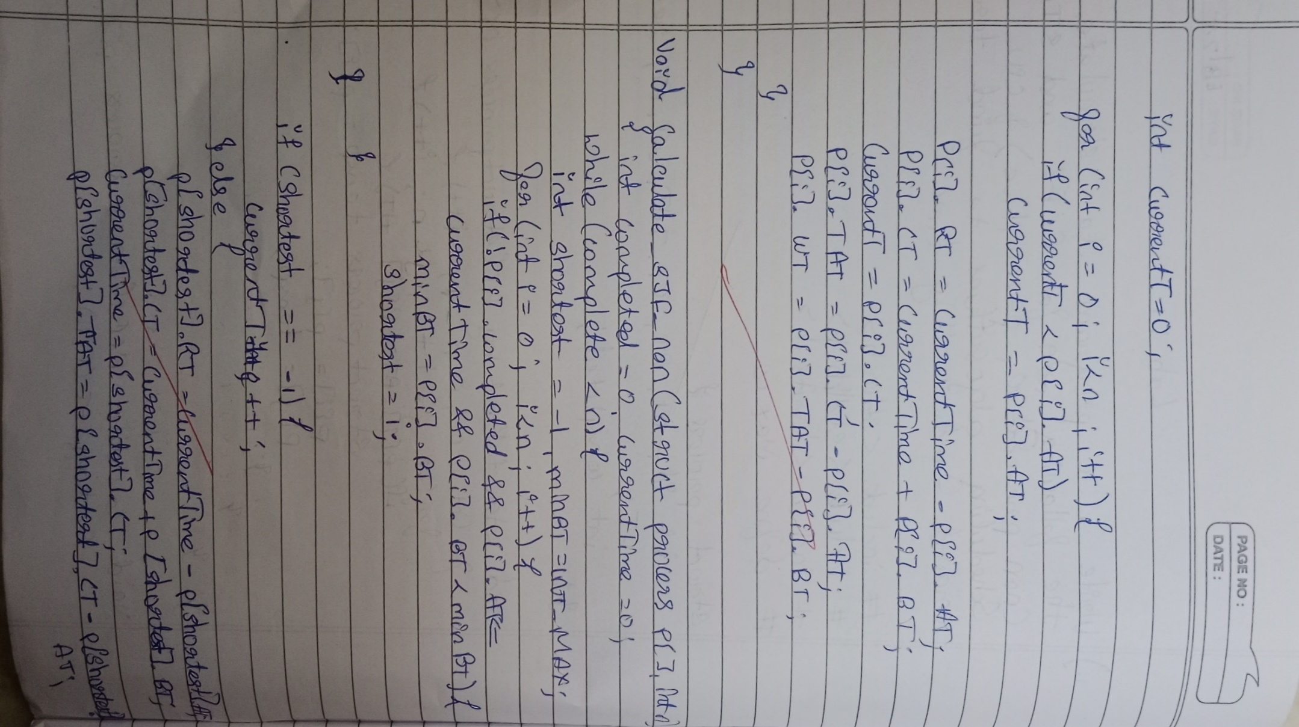

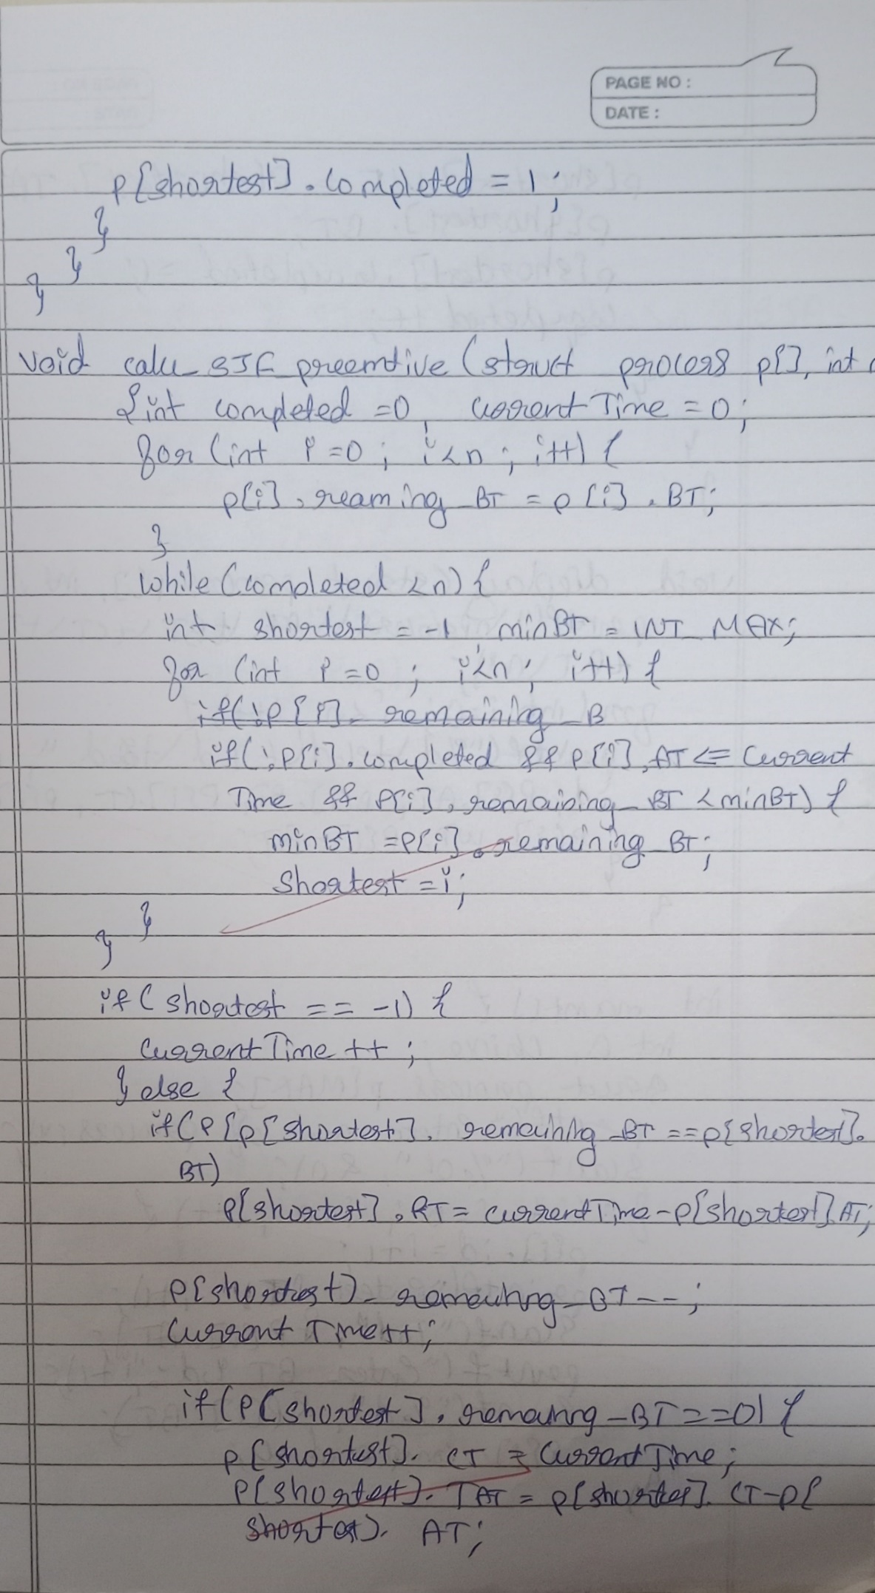

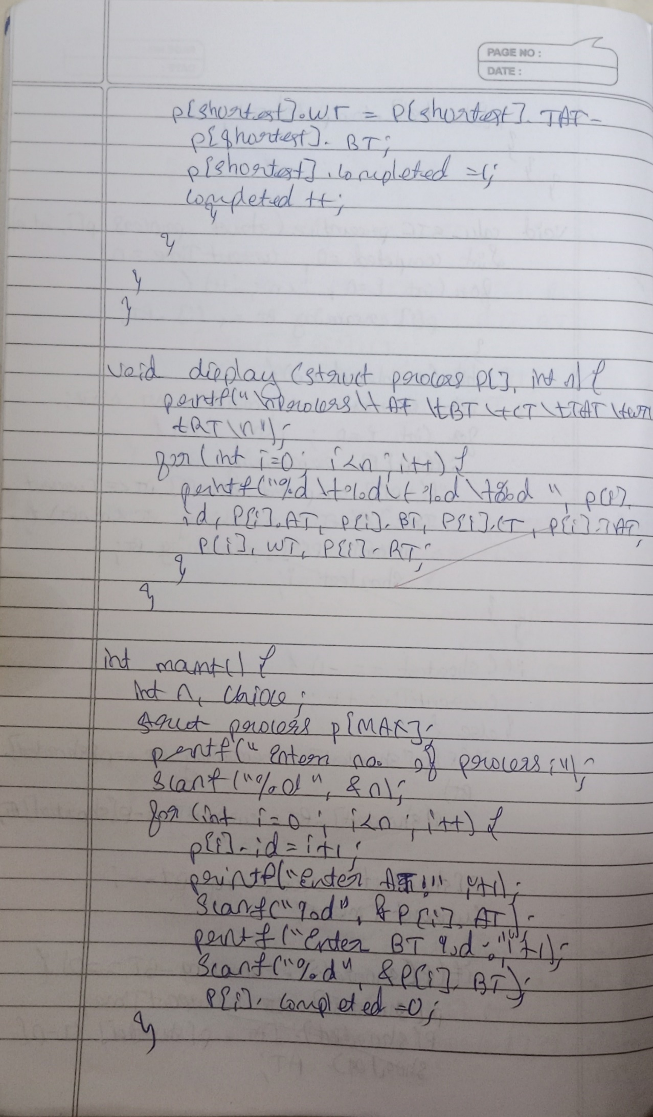

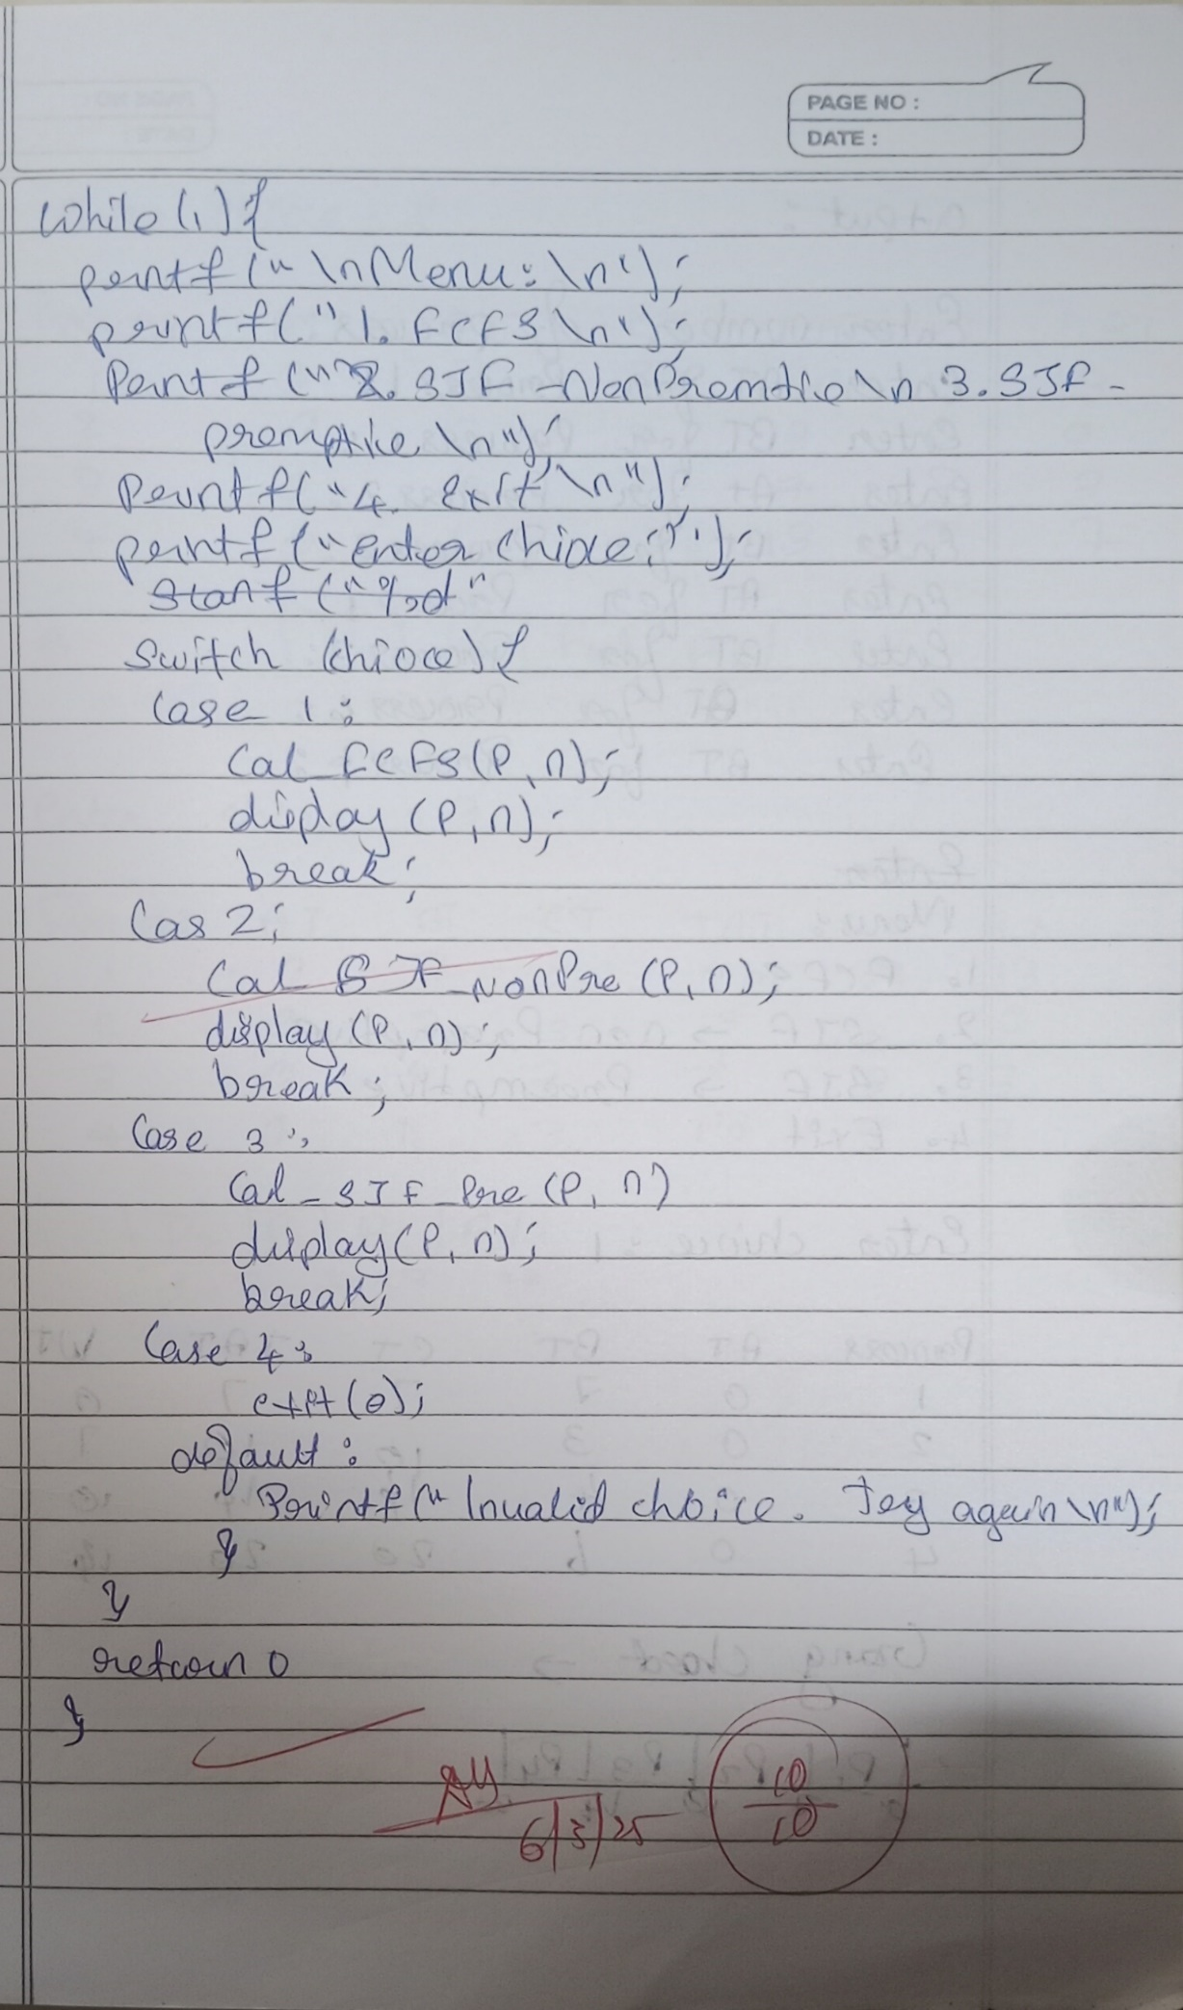

**Lab 2:**

**Write a C program to simulate the following pre-emptive non-pre-emptive CPU scheduling algorithm to find turnaround time and waiting time.**

#include <stdio.h>

#define MAX 10

typedef struct {

int pid, at, bt, pt, remaining_bt, ct, tat, wt, rt, is_completed, st;

} Process;

void nonPreemptivePriority(Process p[], int n) {

int time = 0, completed = 0;

while (completed < n) {

int highest_priority = 9999, selected = -1;

for (int i = 0; i < n; i++) {

if (p[i].at <= time && !p[i].is_completed && p[i].pt < highest_priority) {

highest_priority = p[i].pt;

selected = i;

}

}

if (selected == -1) {

time++;

continue;

}

if (p[selected].rt == -1) {

p[selected].st = time;

p[selected].rt = time - p[selected].at;

}

time += p[selected].bt;

p[selected].ct = time;

p[selected].tat = p[selected].ct - p[selected].at;

p[selected].wt = p[selected].tat - p[selected].bt;

p[selected].is_completed = 1;

completed++;

}

}

void preemptivePriority(Process p[], int n) {

int time = 0, completed = 0;

while (completed < n) {

int highest_priority = 9999, selected = -1;

for (int i = 0; i < n; i++) {

if (p[i].at <= time && p[i].remaining_bt > 0 && p[i].pt < highest_priority) {

highest_priority = p[i].pt;

selected = i;

}

}

if (selected == -1) {

time++;

continue;

}

if (p[selected].rt == -1) {

p[selected].st = time;

p[selected].rt = time - p[selected].at;

}

p[selected].remaining_bt--;

time++;

if (p[selected].remaining_bt == 0) {

p[selected].ct = time;

p[selected].tat = p[selected].ct - p[selected].at;

p[selected].wt = p[selected].tat - p[selected].bt;

completed++;

}

}

}

void displayProcesses(Process p[], int n) {

float avg_tat = 0, avg_wt = 0, avg_rt = 0;

printf("\nPID\tAT\tBT\tPriority\tCT\tTAT\tWT\tRT\n");

for (int i = 0; i < n; i++) {

printf("%d\t%d\t%d\t%d\t\t%d\t%d\t%d\t%d\n",

p[i].pid, p[i].at, p[i].bt, p[i].pt, p[i].ct, p[i].tat, p[i].wt, p[i].rt);

avg_tat += p[i].tat;

avg_wt += p[i].wt;

avg_rt += p[i].rt;

}

printf("\nAverage TAT: %.2f", avg_tat / n);

printf("\nAverage WT: %.2f", avg_wt / n);

printf("\nAverage RT: %.2f\n", avg_rt / n);

}

int main() {

Process p[MAX];

int n, choice;

printf("Enter the number of processes: ");

scanf("%d", &n);

for (int i = 0; i < n; i++) {

p[i].pid = i + 1;

printf("\nEnter Arrival Time, Burst Time, and Priority for Process %d:\n", p[i].pid);

printf("Arrival Time: ");

scanf("%d", &p[i].at);

printf("Burst Time: ");

scanf("%d", &p[i].bt);

printf("Priority : ");

scanf("%d", &p[i].pt);

p[i].remaining_bt = p[i].bt;

p[i].is_completed = 0;

p[i].rt = -1;

}

while (1) {

printf("\nPriority Scheduling Menu:\n");

printf("1. Non-Preemptive Priority Scheduling\n");

printf("2. Preemptive Priority Scheduling\n");

printf("3. Exit\n");

printf("Enter your choice: ");

scanf("%d", &choice);

switch (choice) {

case 1:

nonPreemptivePriority(p, n);

printf("Non-Preemptive Scheduling Completed!\n");

displayProcesses(p, n);

break;

case 2:

preemptivePriority(p, n);

printf("Preemptive Scheduling Completed!\n");

displayProcesses(p, n);

break;

case 3:

printf("Exiting...\n");

return 0;

default:

printf("Invalid choice! Try again.\n");

}

}

return 0;

}

**Output:**

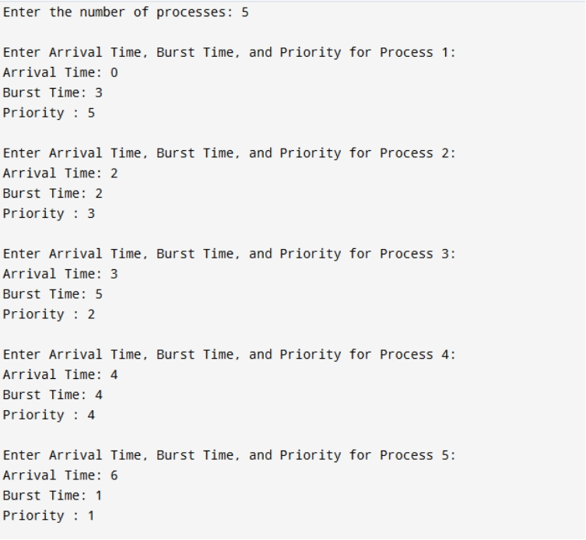

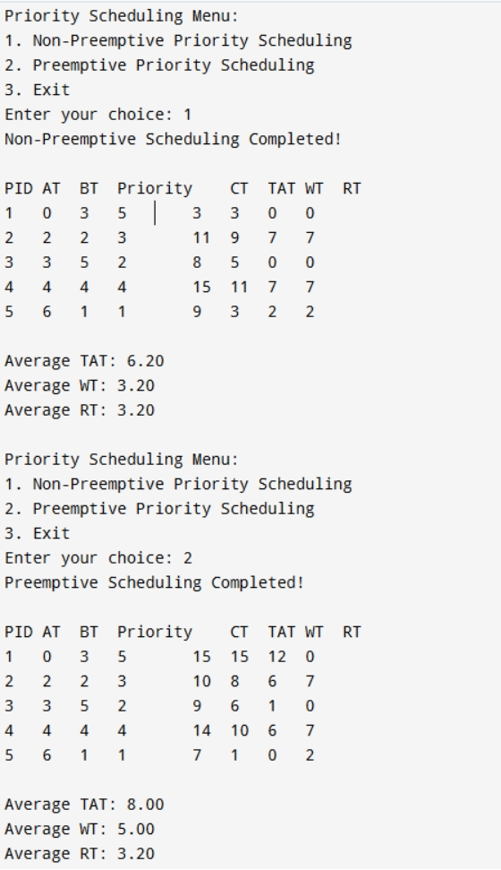

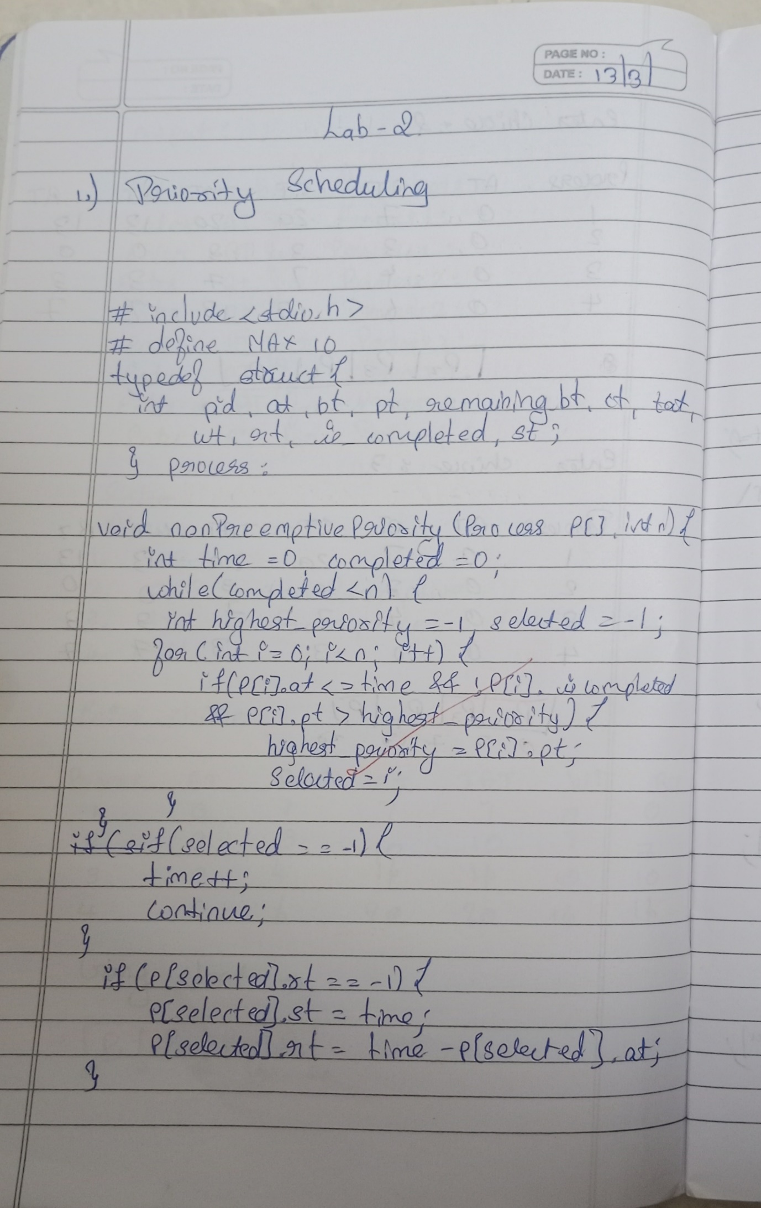

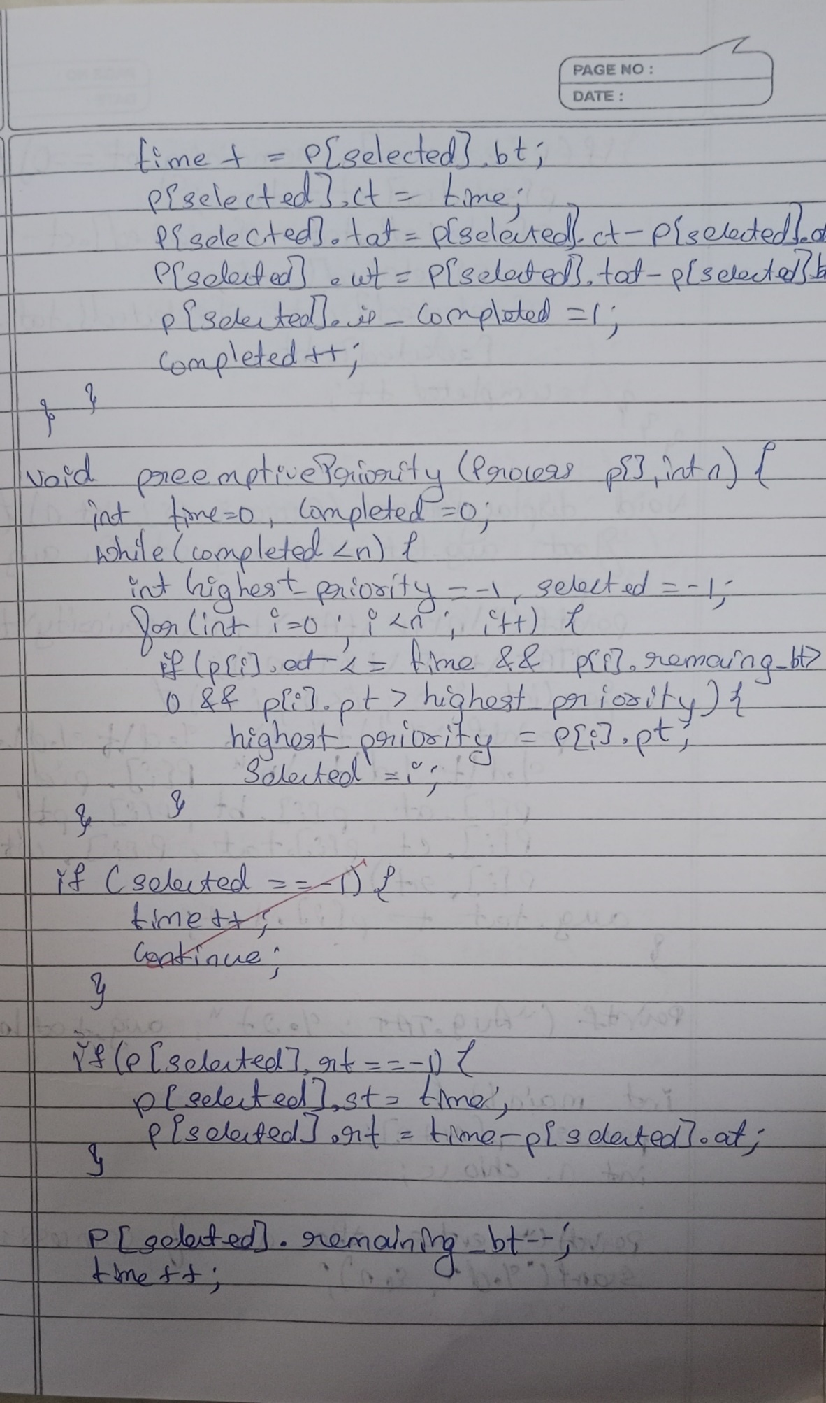

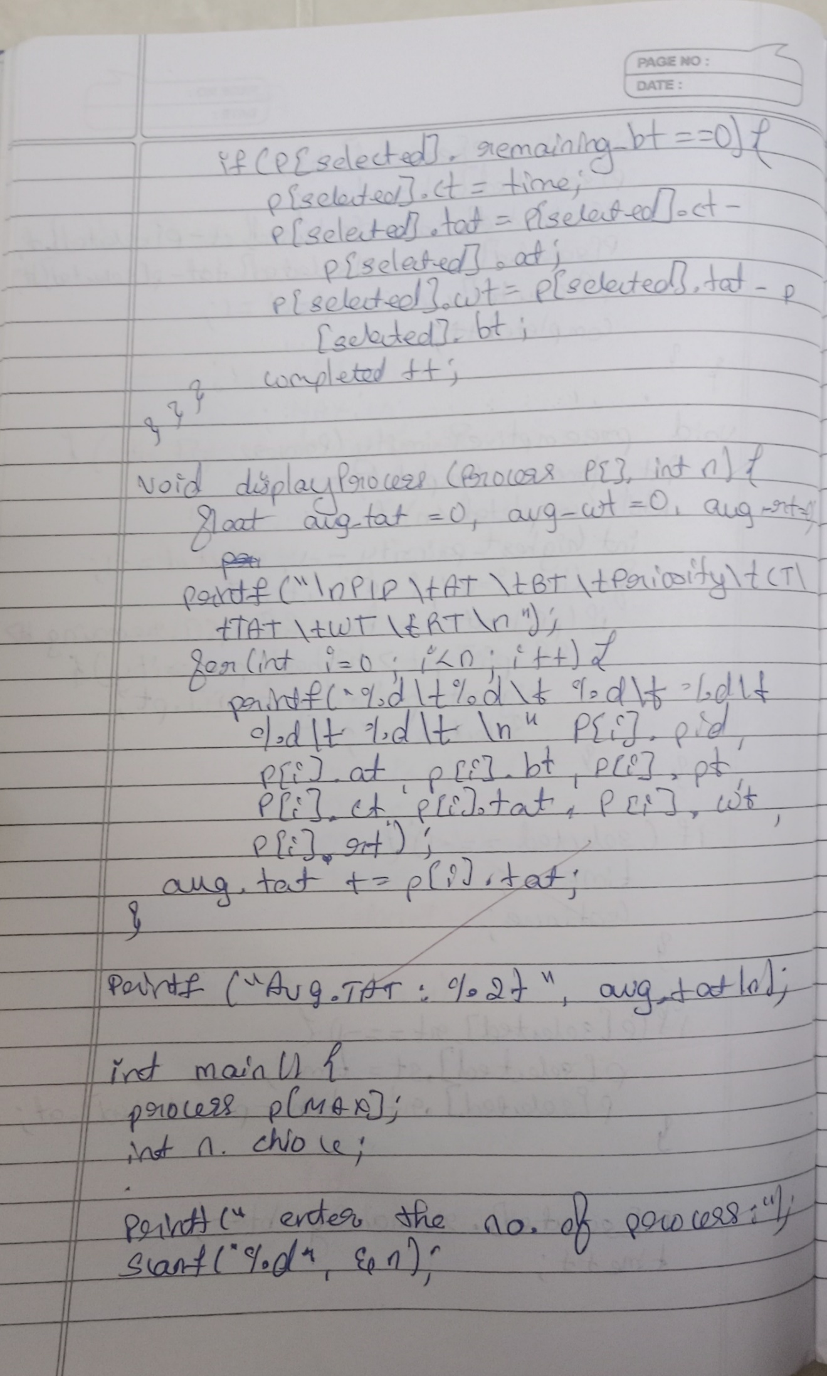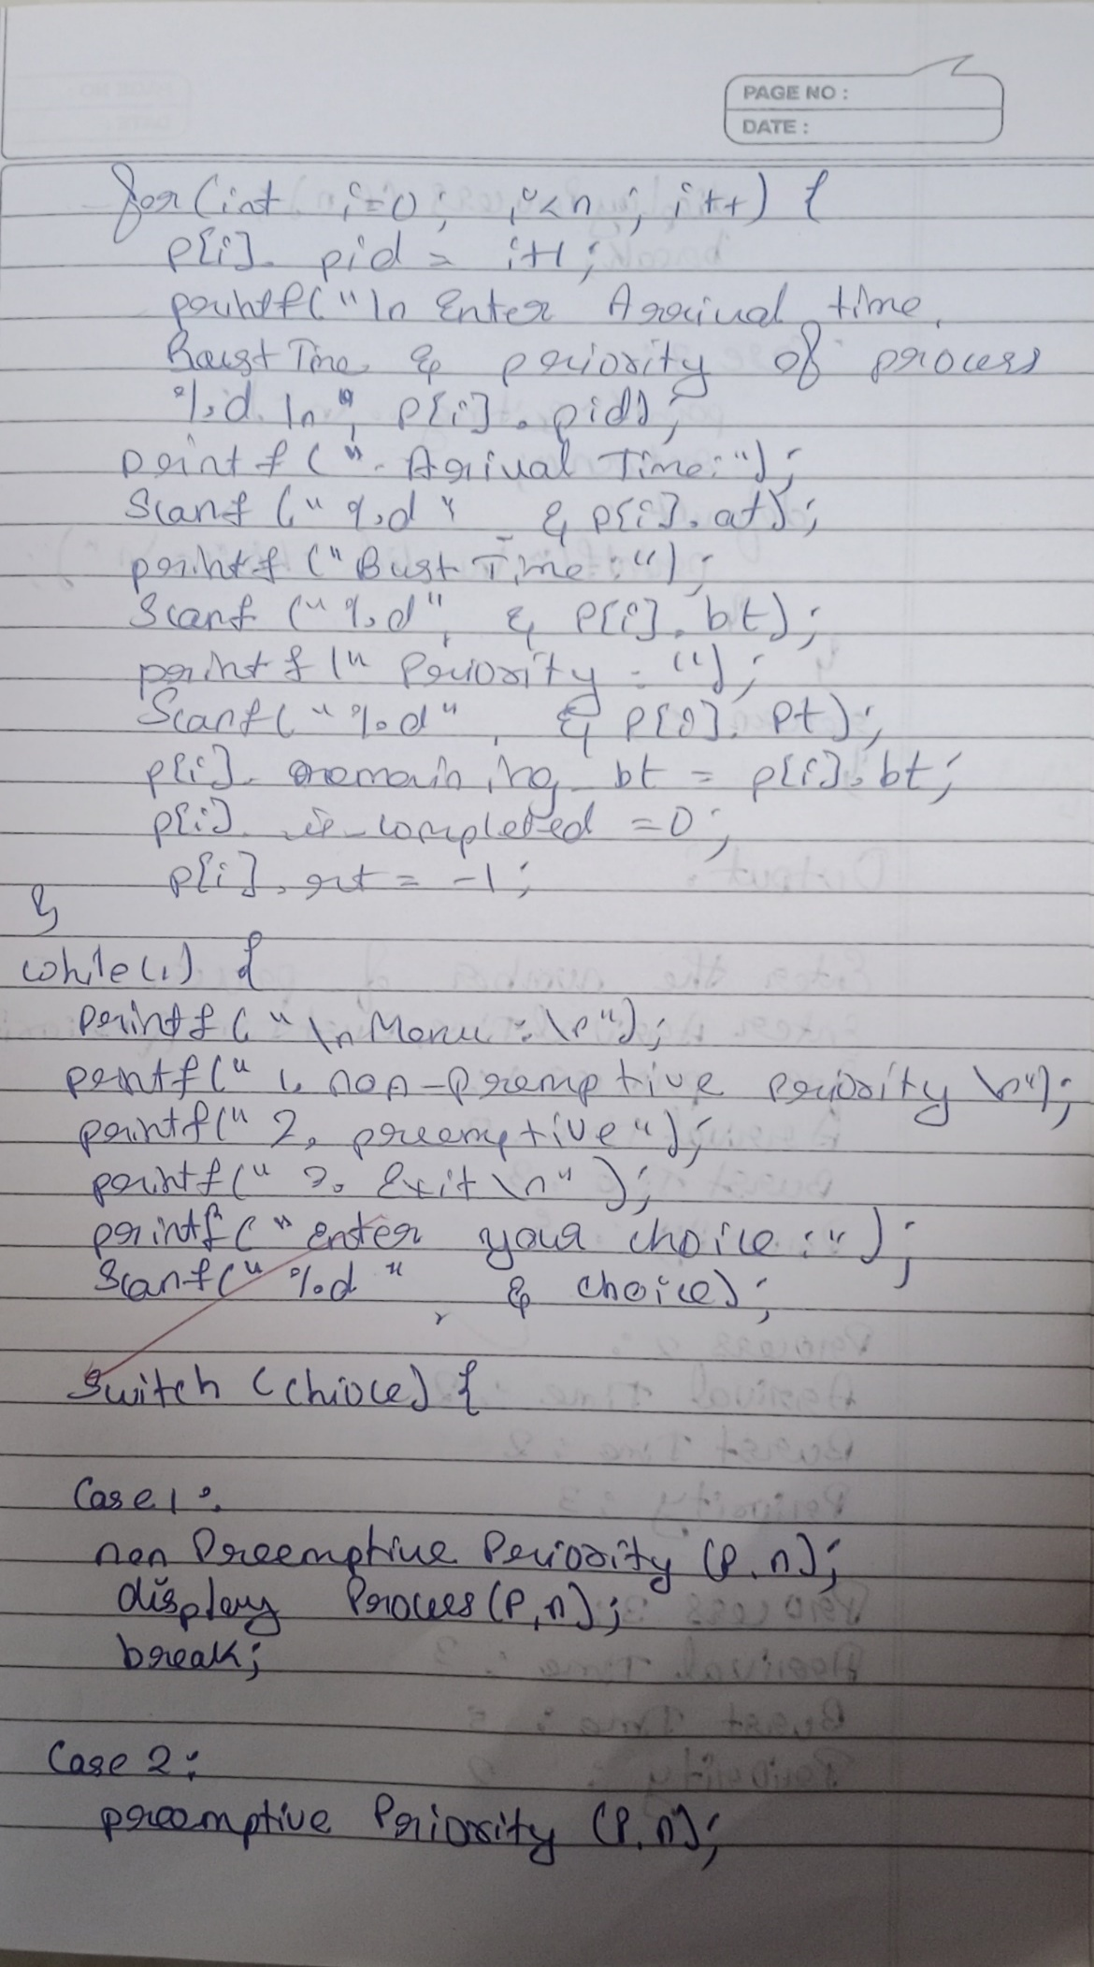

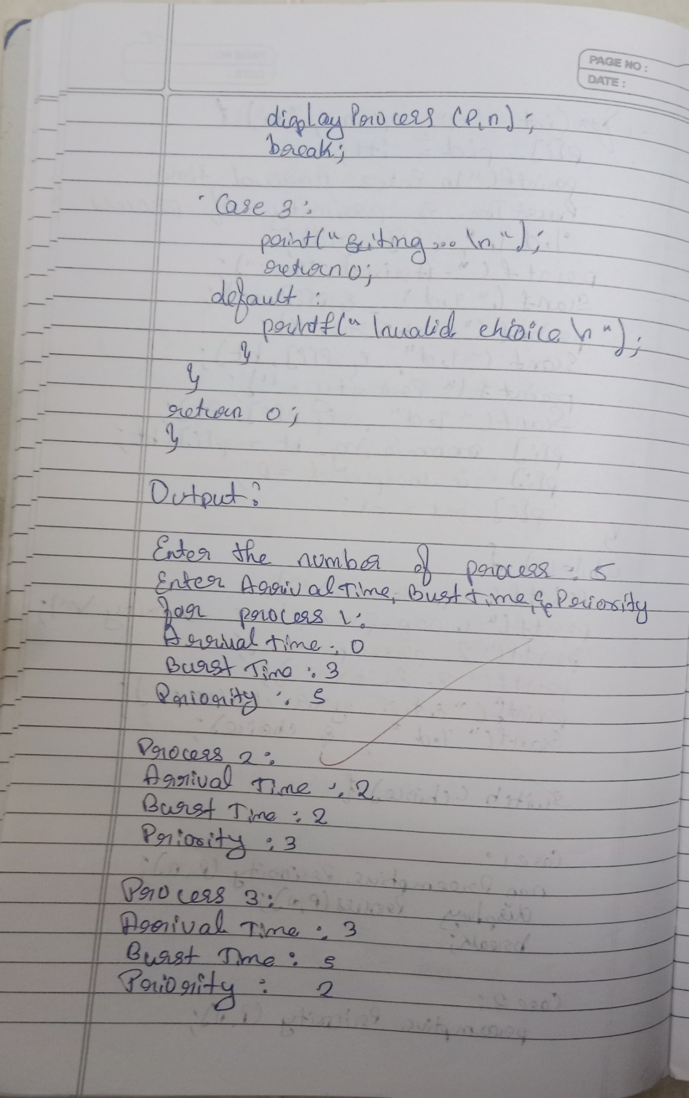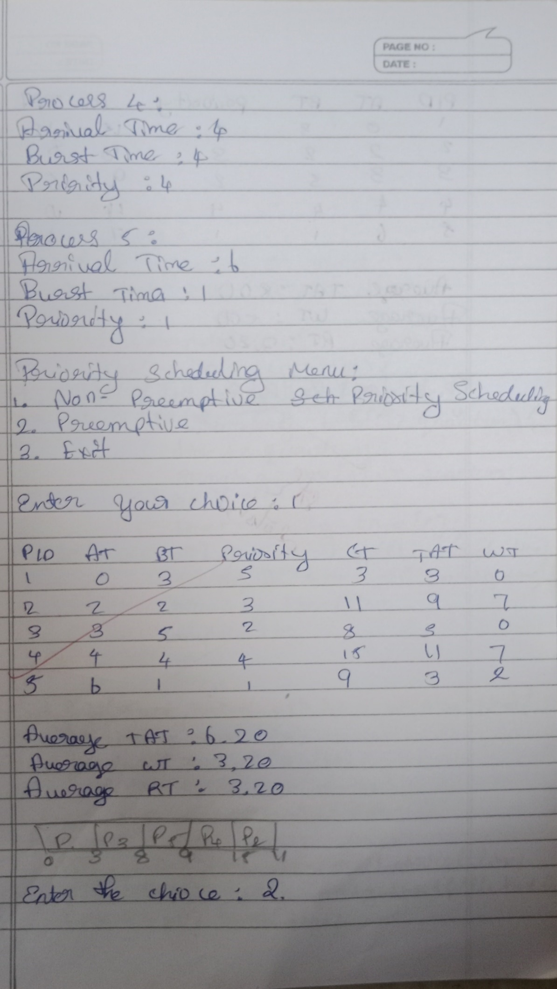

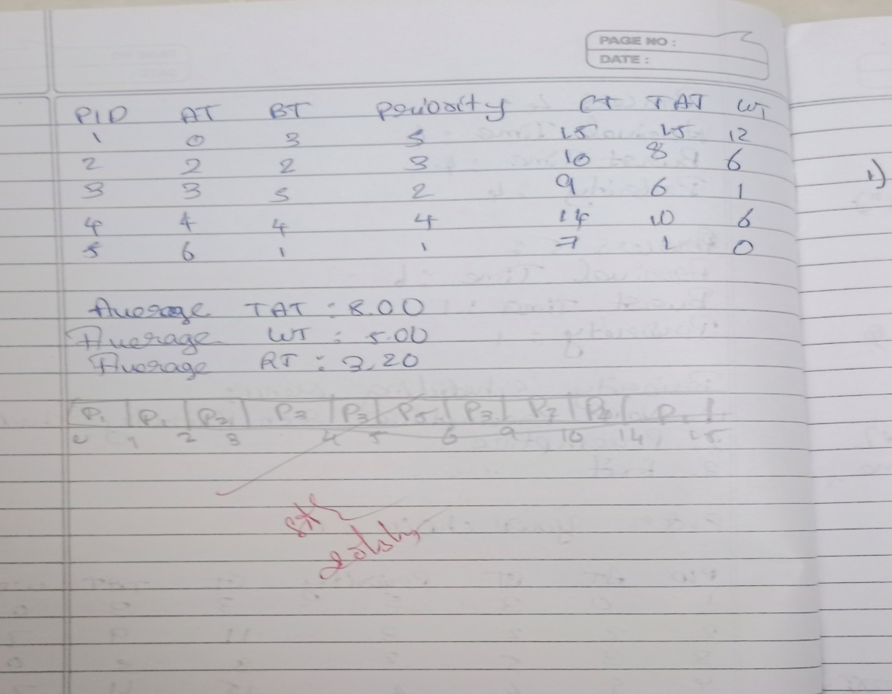

**Lab 3:**

1. **Write a C program to simulate multi-level queue scheduling algorithm considering the following scenario. All the processes in the system are divided into two categories – system processes and user processes. System processes are to be given higher priority than user processes. Use FCFS scheduling for the processes in each queue.**

#include <stdio.h>

struct Process {

int id, burst_time, arrival_time, queue;

int waiting_time, turnaround_time, response_time;

};

void round_robin(struct Process p[], int n, int quantum) {

int remaining_time[n], completed = 0, time = 0;

for (int i = 0; i < n; i++) remaining_time[i] = p[i].burst_time;

while (completed < n) {

for (int i = 0; i < n; i++) {

if (remaining_time[i] > 0) {

if (remaining_time[i] > quantum) {

time += quantum;

remaining_time[i] -= quantum;

} else {

time += remaining_time[i];

p[i].waiting_time = time - p[i].arrival_time - p[i].burst_time;

p[i].turnaround_time = time - p[i].arrival_time;

p[i].response_time = p[i].waiting_time;

remaining_time[i] = 0;

completed++;

}

}

}

}

}

void fcfs(struct Process p[], int n, int start_time) {

int time = start_time;

for (int i = 0; i < n; i++) {

if (time < p[i].arrival_time)

time = p[i].arrival_time;

p[i].waiting_time = time - p[i].arrival_time;

p[i].turnaround_time = p[i].waiting_time + p[i].burst_time;

p[i].response_time = p[i].waiting_time;

time += p[i].burst_time;

}

}

int main() {

int n;

printf("Enter number of processes: ");

scanf("%d", &n);

struct Process processes[n], system_queue[n], user_queue[n];

int sys_count = 0, user_count = 0;

printf("Enter Burst Time, Arrival Time and Queue of each process: \n");

for (int i = 0; i < n; i++) {

printf("P%d: ", i + 1);

scanf("%d %d %d", &processes[i].burst_time, &processes[i].arrival_time, &processes[i].queue);

processes[i].id = i + 1;

if (processes[i].queue == 1)

system_queue[sys_count++] = processes[i];

else if (processes[i].queue == 2)

user_queue[user_count++] = processes[i];

}

int quantum = 2;

round_robin(system_queue, sys_count, quantum);

int last_exec_time = (sys_count > 0) ? system_queue[sys_count - 1].turnaround_time : 0;

fcfs(user_queue, user_count, last_exec_time);

printf("\nProcess\tWT\tTAT\tRt\n");

for (int i = 0; i < sys_count; i++)

printf("P%d\t%d\t%d\t%d\n", system_queue[i].id, system_queue[i].waiting_time, system_queue[i].turnaround_time, system_queue[i].response_time);

for (int i = 0; i < user_count; i++)

printf("P%d\t%d\t%d\t%d\n", user_queue[i].id, user_queue[i].waiting_time, user_queue[i].turnaround_time, user_queue[i].response_time);

float avg_wait = 0, avg_tat = 0, avg_resp = 0;

for (int i = 0; i < sys_count; i++) {

avg_wait += system_queue[i].waiting_time;

avg_tat += system_queue[i].turnaround_time;

avg_resp += system_queue[i].response_time;

}

for (int i = 0; i < user_count; i++) {

avg_wait += user_queue[i].waiting_time;

avg_tat += user_queue[i].turnaround_time;

avg_resp += user_queue[i].response_time;

}

int total = sys_count + user_count;

printf("\nAverage Waiting Time: %.2f", avg_wait / total);

printf("\nAverage Turn Around Time: %.2f", avg_tat / total);

printf("\nAverage Response Time: %.2f", avg_resp / total);

printf("\nThroughput: %.2f\n", (float)total / avg_tat * total);

return 0;

}

**Output:**

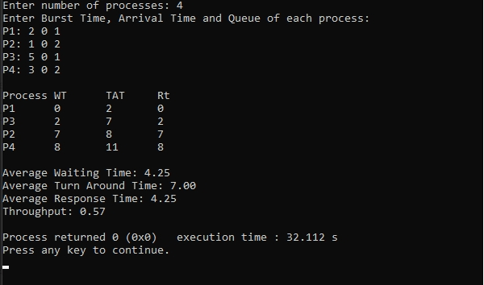

1. **Rate- Monotonic**

#include <stdio.h>

#define MAX_PROCESSES 10

typedef struct {

int id;

int burst_time;

int period;

int remaining_time;

int next_deadline;

} Process;

void sort_by_period(Process processes[], int n) {

for (int i = 0; i < n - 1; i++) {

for (int j = 0; j < n - i - 1; j++) {

if (processes[j].period > processes[j + 1].period) {

Process temp = processes[j];

processes[j] = processes[j + 1];

processes[j + 1] = temp;

}

}

}

}

int gcd(int a, int b) {

return b == 0 ? a : gcd(b, a % b);

}

int lcm(int a, int b) {

return (a * b) / gcd(a, b);

}

int calculate_lcm(Process processes[], int n) {

int result = processes[0].period;

for (int i = 1; i < n; i++) {

result = lcm(result, processes[i].period);

}

return result;

}

double utilization_factor(Process processes[], int n) {

double sum = 0;

for (int i = 0; i < n; i++) {

sum += (double)processes[i].burst_time / processes[i].period;

}

return sum;

}

double rms_threshold(int n) {

return n * (pow(2.0, 1.0 / n) - 1);

}

void rate_monotonic_scheduling(Process processes[], int n) {

int lcm_period = calculate_lcm(processes, n);

printf("LCM=%d\n\n", lcm_period);

printf("Rate Monotone Scheduling:\n");

printf("PID Burst Period\n");

for (int i = 0; i < n; i++) {

printf("%d %d %d\n", processes[i].id, processes[i].burst_time, processes[i].period);

}

double utilization = utilization_factor(processes, n);

double threshold = rms_threshold(n);

printf("\n%.6f <= %.6f => %s\n", utilization, threshold, (utilization <= threshold) ? "true" : "false");

if (utilization > threshold) {

printf("\nSystem may not be schedulable!\n");

return;

}

int timeline = 0, executed = 0;

while (timeline < lcm_period) {

int selected = -1;

for (int i = 0; i < n; i++) {

if (timeline % processes[i].period == 0) {

processes[i].remaining_time = processes[i].burst_time;

}

if (processes[i].remaining_time > 0) {

selected = i;

break;

}

}

if (selected != -1) {

printf("Time %d: Process %d is running\n", timeline, processes[selected].id);

processes[selected].remaining_time--;

executed++;

} else {

printf("Time %d: CPU is idle\n", timeline);

}

timeline++;

}

}

int main() {

int n;

Process processes[MAX_PROCESSES];

printf("Enter the number of processes: ");

scanf("%d", &n);

printf("Enter the CPU burst times:\n");

for (int i = 0; i < n; i++) {

processes[i].id = i + 1;

scanf("%d", &processes[i].burst_time);

processes[i].remaining_time = processes[i].burst_time;

}

printf("Enter the time periods:\n");

for (int i = 0; i < n; i++) {

scanf("%d", &processes[i].period);

}

sort_by_period(processes, n);

rate_monotonic_scheduling(processes, n);

return 0;

}

**Output:**

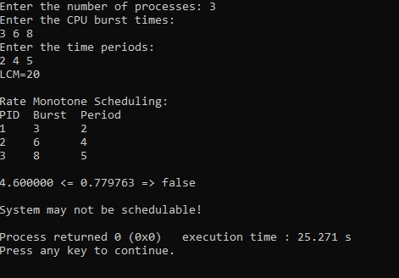

1. **Earliest-deadline First**

int gcd(int a, int b) {  
 while (b != 0) {  
 int temp = b;  
 b = a % b;  
 a = temp;  
 }  
 return a;  
}  
  
int lcm(int a, int b) {  
 return (a * b) / gcd(a, b);  
}  
  
struct Process {  
 int id, burst_time, deadline, period;  
};  
  
void earliest_deadline_first(struct Process p[], int n, int time_limit) {  
 int time = 0;  
 printf("Earliest Deadline Scheduling:\n");  
 printf("PID\tBurst\tDeadline\tPeriod\n");  
 for (int i = 0; i < n; i++) {  
 printf("%d\t%d\t\t%d\t\t%d\n", p[i].id, p[i].burst_time, p[i].deadline, p[i].period);  
 }  
  
 printf("\nScheduling occurs for %d ms\n", time_limit);  
 while (time < time_limit) {  
 int earliest = -1;  
 for (int i = 0; i < n; i++) {  
 if (p[i].burst_time > 0) {  
 if (earliest == -1 || p[i].deadline < p[earliest].deadline) {  
 earliest = i;  
 }  
 }  
 }  
  
 if (earliest == -1) break;  
  
 printf("%dms: Task %d is running.\n", time, p[earliest].id);  
 p[earliest].burst_time--;  
 time++;  
 }  
}  
  
int main() {  
 int n;  
 printf("Enter the number of processes: ");  
 scanf("%d", &n);  
  
 struct Process processes[n];  
 printf("Enter the CPU burst times:\n");  
 for (int i = 0; i < n; i++) {  
 scanf("%d", &processes[i].burst_time);  
 processes[i].id = i + 1;  
 }  
  
 printf("Enter the deadlines:\n");  
 for (int i = 0; i < n; i++) {  
 scanf("%d", &processes[i].deadline);  
 }  
  
 printf("Enter the time periods:\n");  
 for (int i = 0; i < n; i++) {  
 scanf("%d", &processes[i].period);  
 }  
  
 int hyperperiod = processes[0].period;  
 for (int i = 1; i < n; i++) {  
 hyperperiod = lcm(hyperperiod, processes[i].period);  
 }  
  
 printf("\nSystem will execute for hyperperiod (LCM of periods): %d ms\n", hyperperiod);  
  
 earliest_deadline_first(processes, n, hyperperiod);  
  
 return 0;  
}

**Output:**

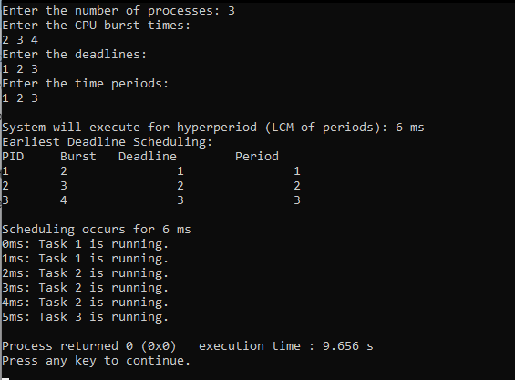

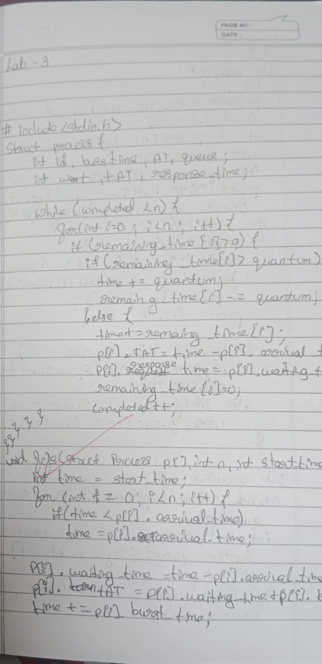

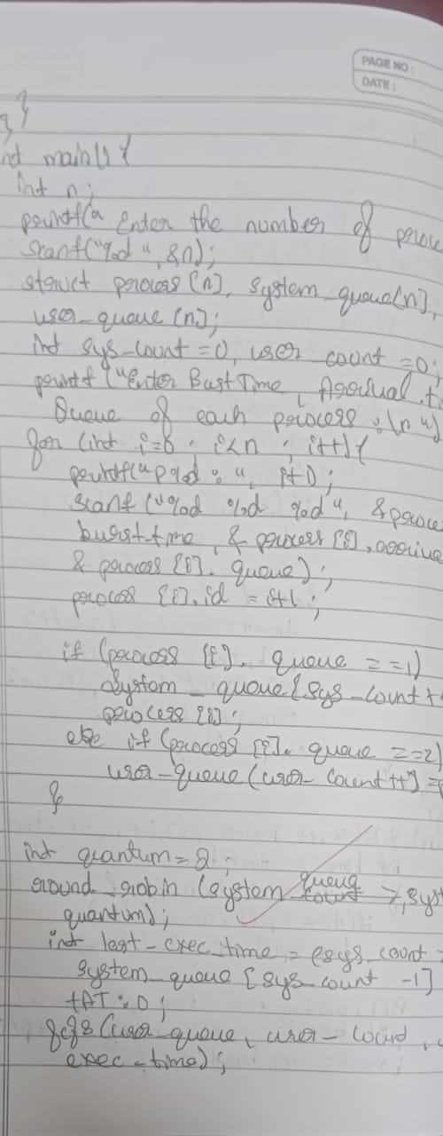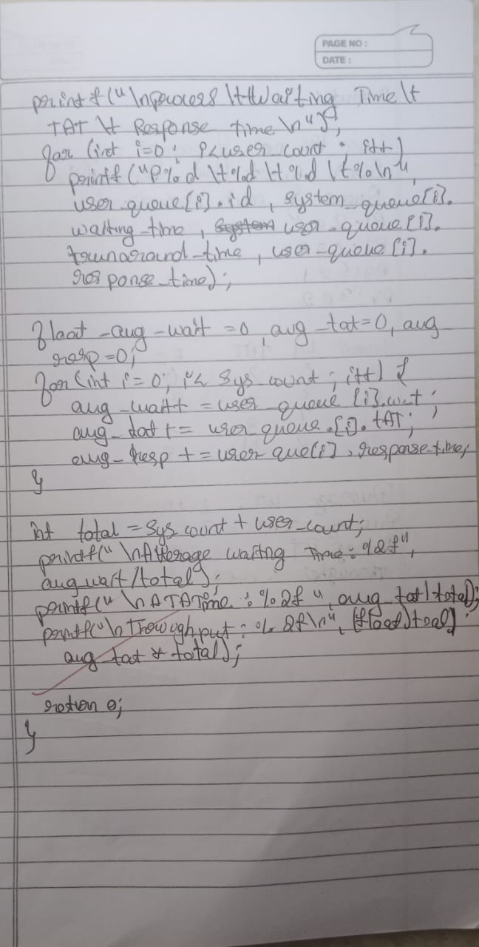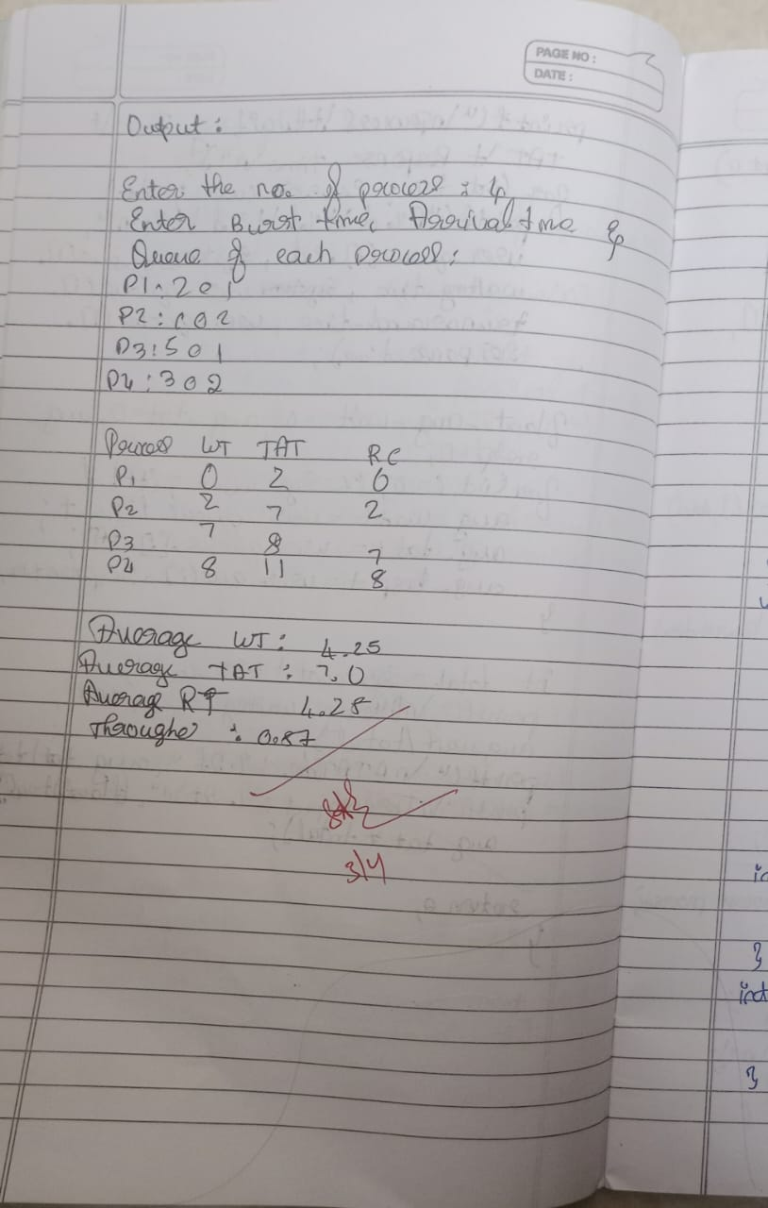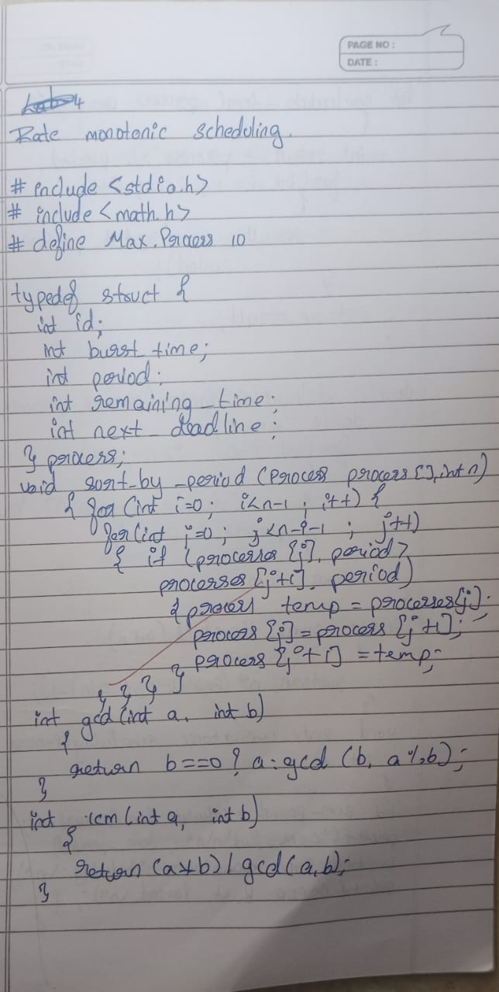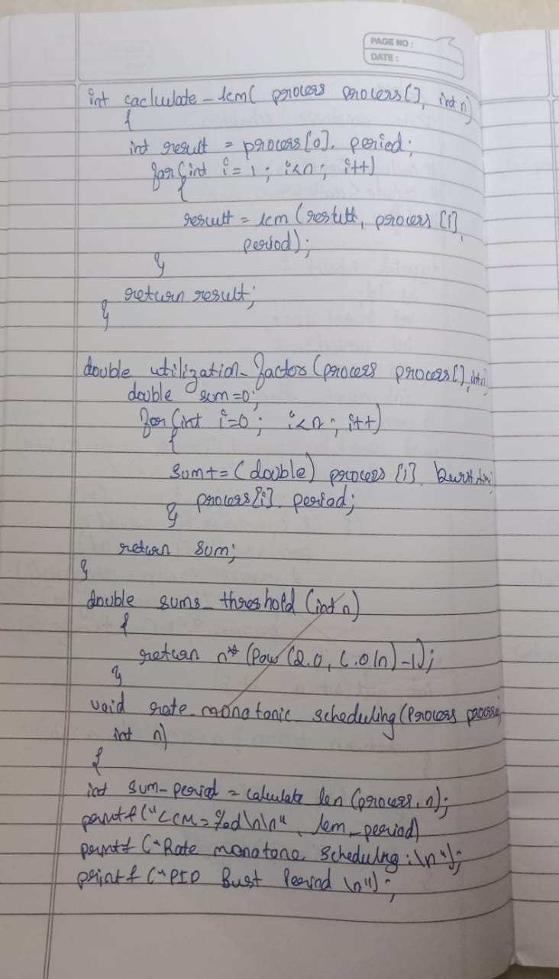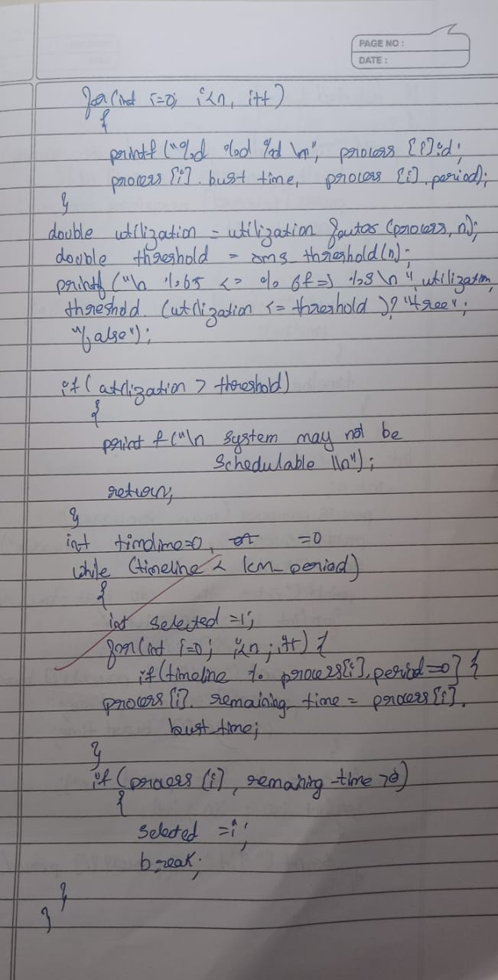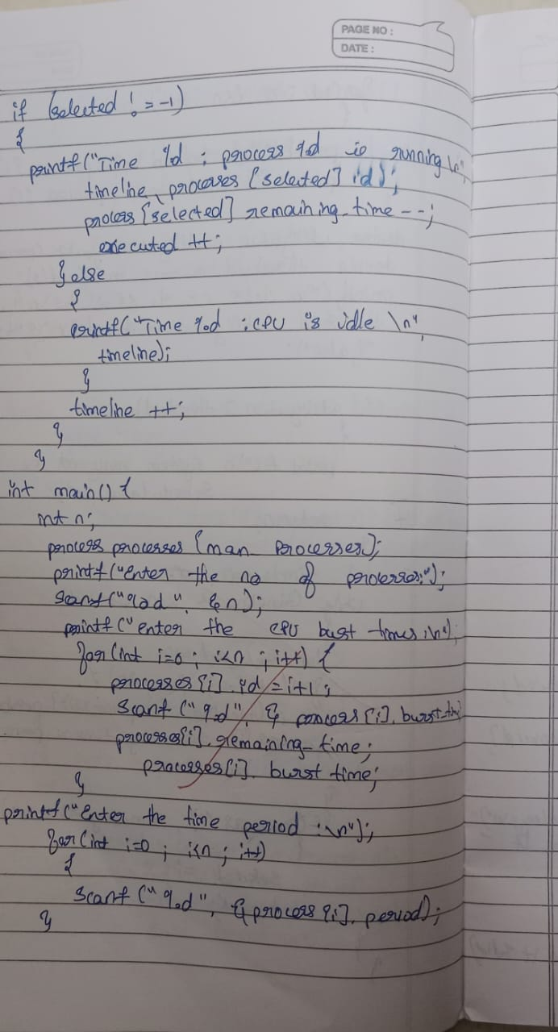

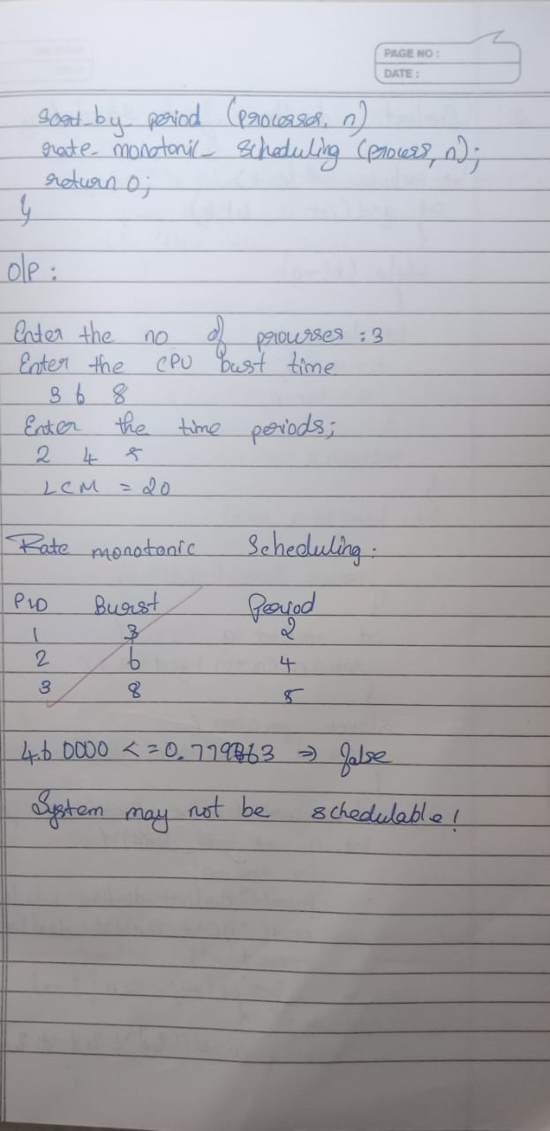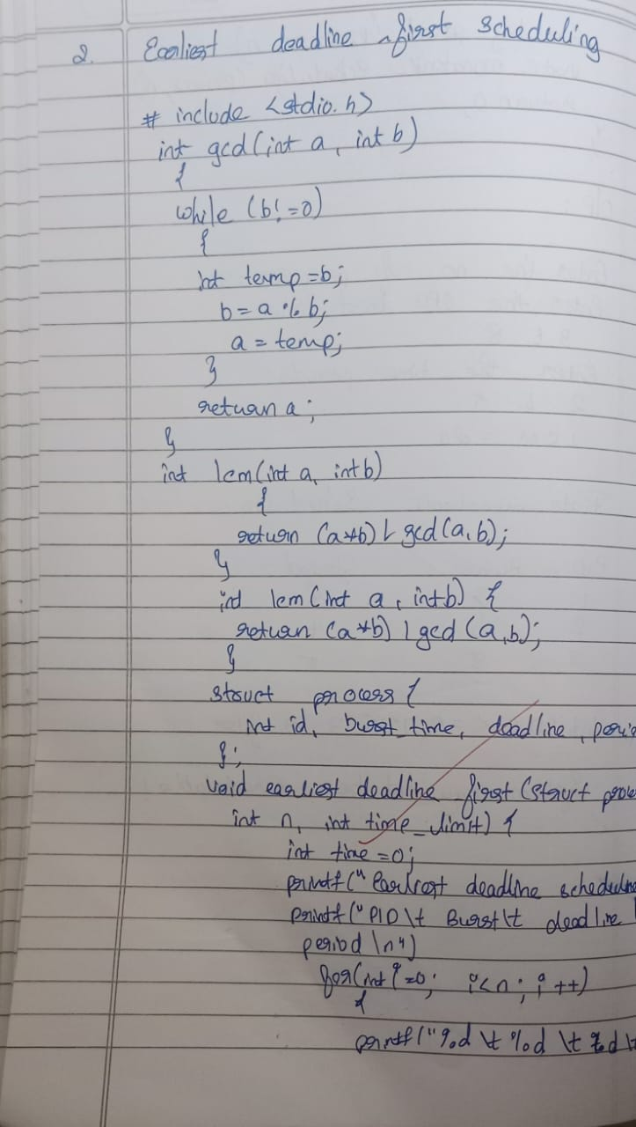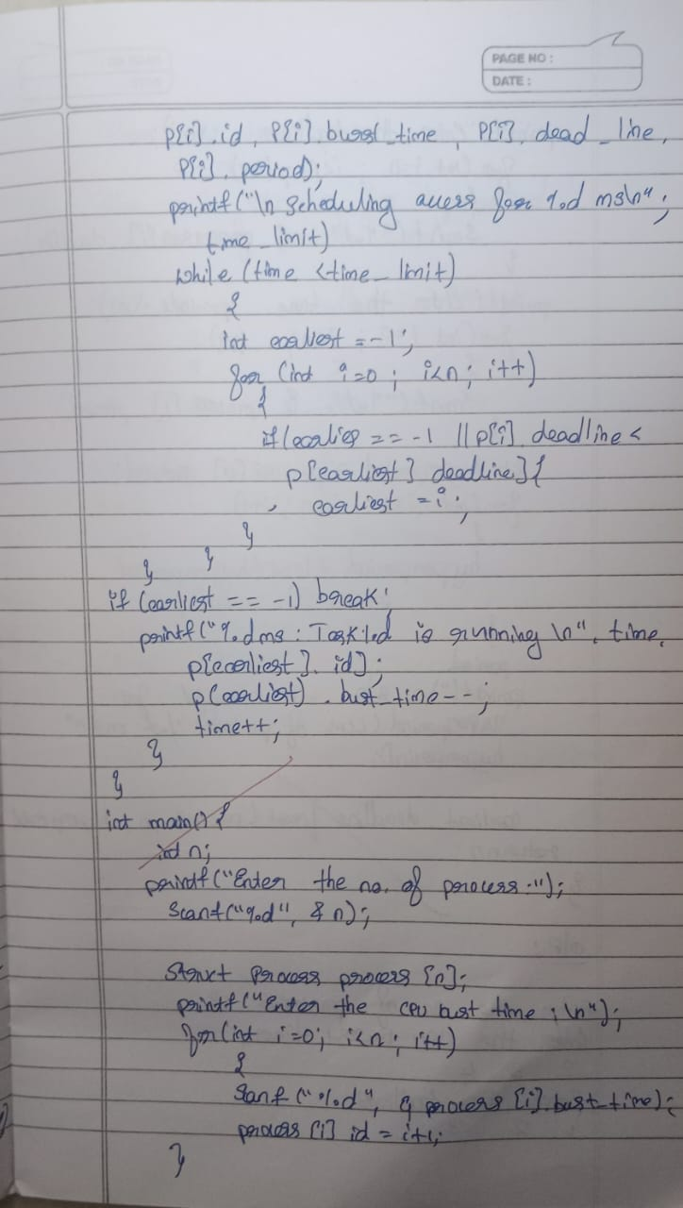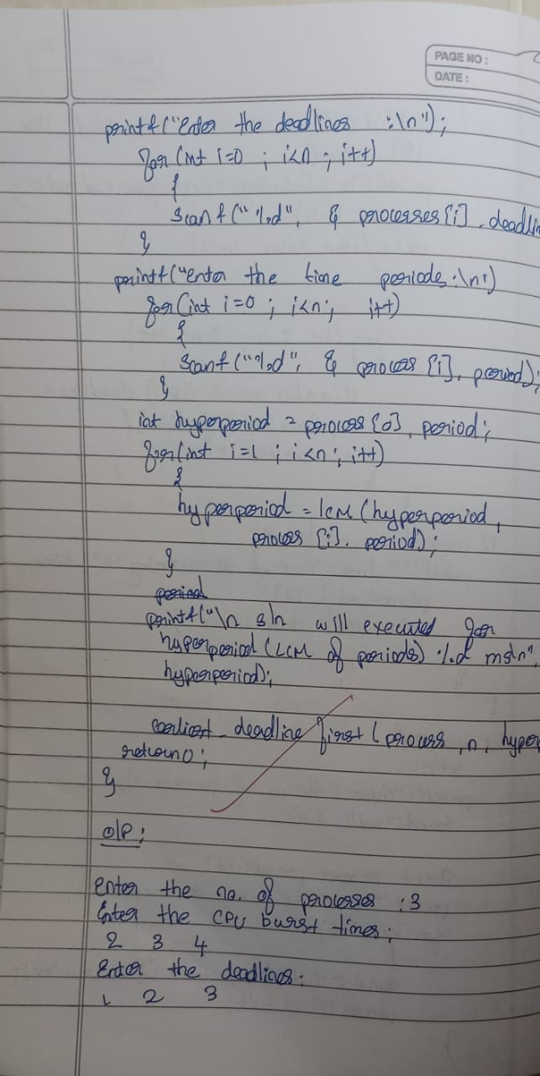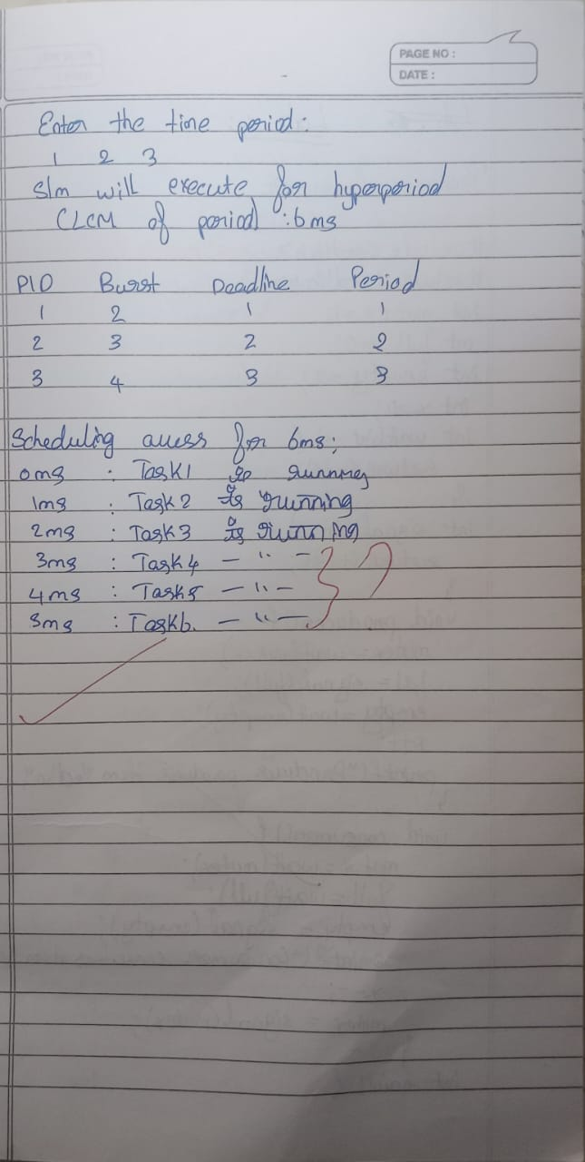

**Lab 4:**

1. **Write a C program to simulate producer-consumer problem**

**using semaphores**

#include <stdio.h>

#include <stdbool.h>

int main() {

int n, m;

printf("Enter number of processes and resources:\n");

scanf("%d %d", &n, &m);

int alloc[n][m], max[n][m], avail[m];

printf("Enter allocation matrix:\n");

for (int i = 0; i < n; i++)

for (int j = 0; j < m; j++)

scanf("%d", &alloc[i][j]);

printf("Enter max matrix:\n");

for (int i = 0; i < n; i++)

for (int j = 0; j < m; j++)

scanf("%d", &max[i][j]);

printf("Enter available matrix:\n");

for (int i = 0; i < m; i++)

scanf("%d", &avail[i]);

int need[n][m];

for (int i = 0; i < n; i++)

for (int j = 0; j < m; j++)

need[i][j] = max[i][j] - alloc[i][j];

bool finish[n];

for (int i = 0; i < n; i++)

finish[i] = false;

int safeSeq[n];

int work[m];

for (int i = 0; i < m; i++)

work[i] = avail[i];

int count = 0;

while (count < n) {

bool found = false;

for (int p = 0; p < n; p++) {

if (!finish[p]) {

int j;

for (j = 0; j < m; j++)

if (need[p][j] > work[j])

break;

if (j == m) {

for (int k = 0; k < m; k++)

work[k] += alloc[p][k];

safeSeq[count++] = p;

finish[p] = true;

found = true;

}

}

}

if (!found) {

printf("System is not in a safe state.\n");

return 0;

}

}

printf("System is in safe state.\nSafe sequence is: ");

for (int i = 0; i < n; i++)

printf("P%d%s", safeSeq[i], (i == n - 1) ? "\n" : " -> ");

return 0;

}

**Output:**

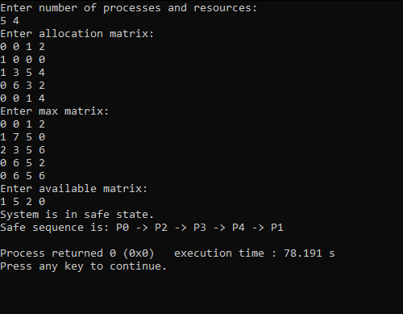

1. **Write a C program to simulate the concept of Dining Philosophers problem.**

#include <stdio.h>

#include <stdlib.h>

#define MAX 10

int totalPhilosophers;

int hungry[MAX];

int areNeighbors(int a, int b) {

return (abs(a - b) == 1 || abs(a - b) == totalPhilosophers - 1);

}

void option1(int count) {

printf("\nAllow one philosopher to eat at any time\n");

for (int i = 0; i < count; i++) {

printf("P %d is granted to eat\n", hungry[i]);

for (int j = 0; j < count; j++) {

if (j != i) {

printf("P %d is waiting\n", hungry[j]);

}

}

}

}

void option2(int count) {

printf("\nAllow two philosophers to eat at same time\n");

int combination = 1;

for (int i = 0; i < count; i++) {

for (int j = i + 1; j < count; j++) {

if (!areNeighbors(hungry[i], hungry[j])) {

printf("combination %d\n", combination++);

printf("P %d and P %d are granted to eat\n", hungry[i], hungry[j]);

for (int k = 0; k < count; k++) {

if (k != i && k != j) {

printf("P %d is waiting\n", hungry[k]);

}

}

printf("\n");

}

}

}

if (combination == 1) {

printf("No combinations found where two non-neighbor philosophers can eat.\n");

}

}

int main() {

int hungryCount;

printf("DINING PHILOSOPHER PROBLEM\n");

printf("Enter the total no. of philosophers: ");

scanf("%d", &totalPhilosophers);

printf("How many are hungry: ");

scanf("%d", &hungryCount);

for (int i = 0; i < hungryCount; i++) {

printf("Enter philosopher %d position: ", i + 1);

scanf("%d", &hungry[i]);

}

int choice;

do {

printf("\n1. One can eat at a time 2. Two can eat at a time 3. Exit\n");

printf("Enter your choice: ");

scanf("%d", &choice);

switch (choice) {

case 1:

option1(hungryCount);

break;

case 2:

option2(hungryCount);

break;

case 3:

printf("Exiting...\n");

break;

default:

printf("Invalid choice!\n");

}

} while (choice != 3);

return 0;

**Output:**

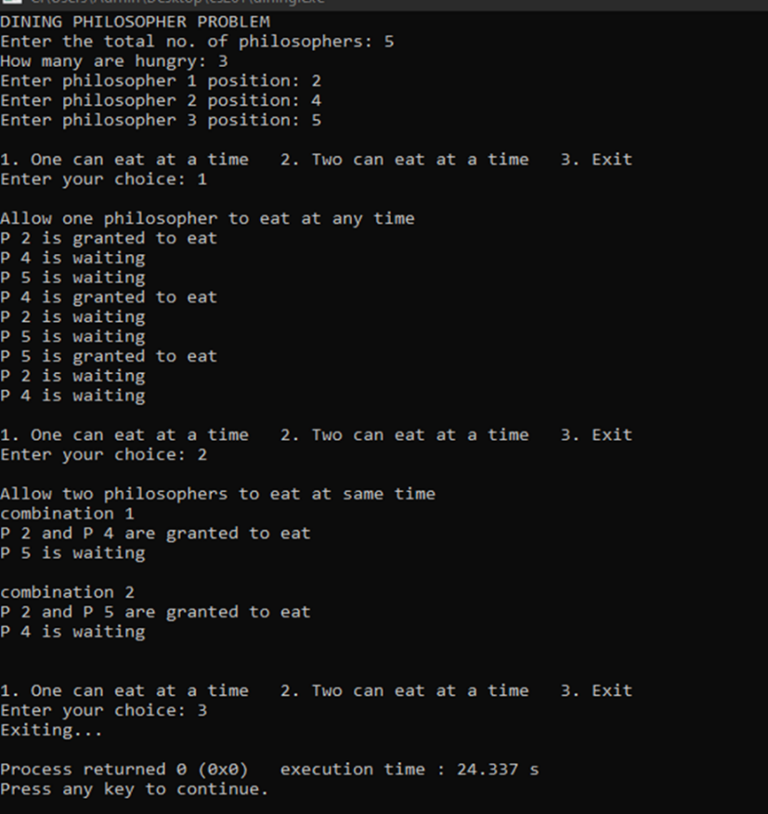

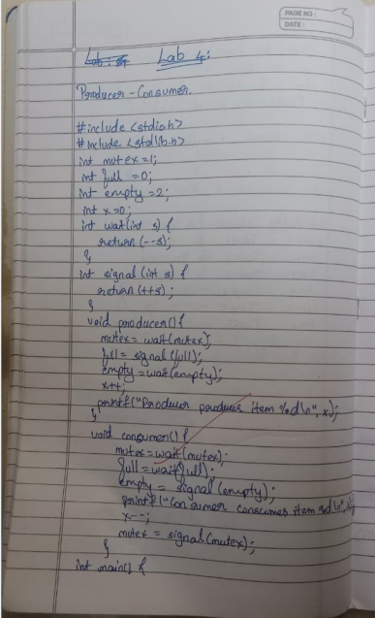

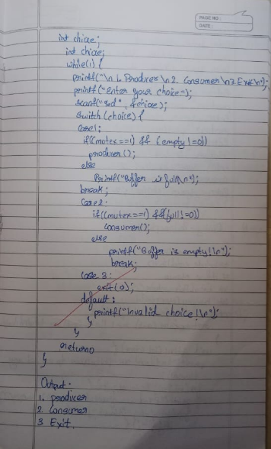

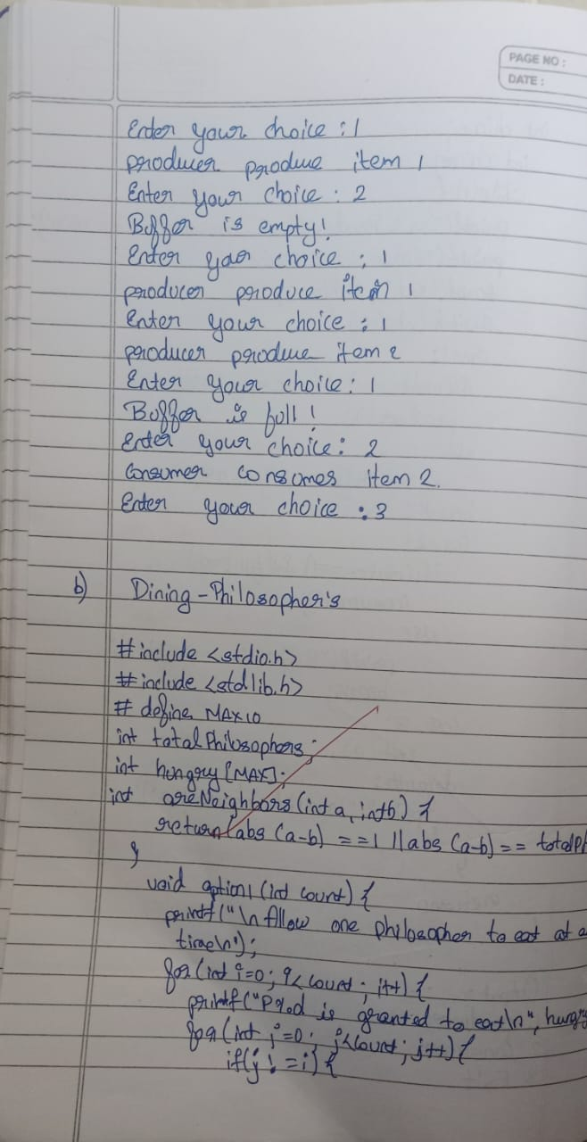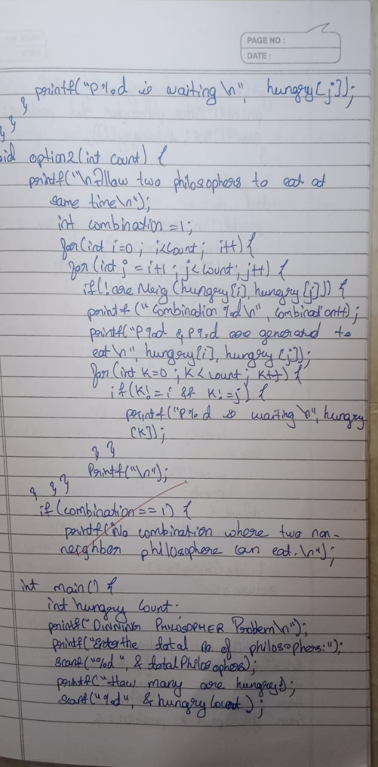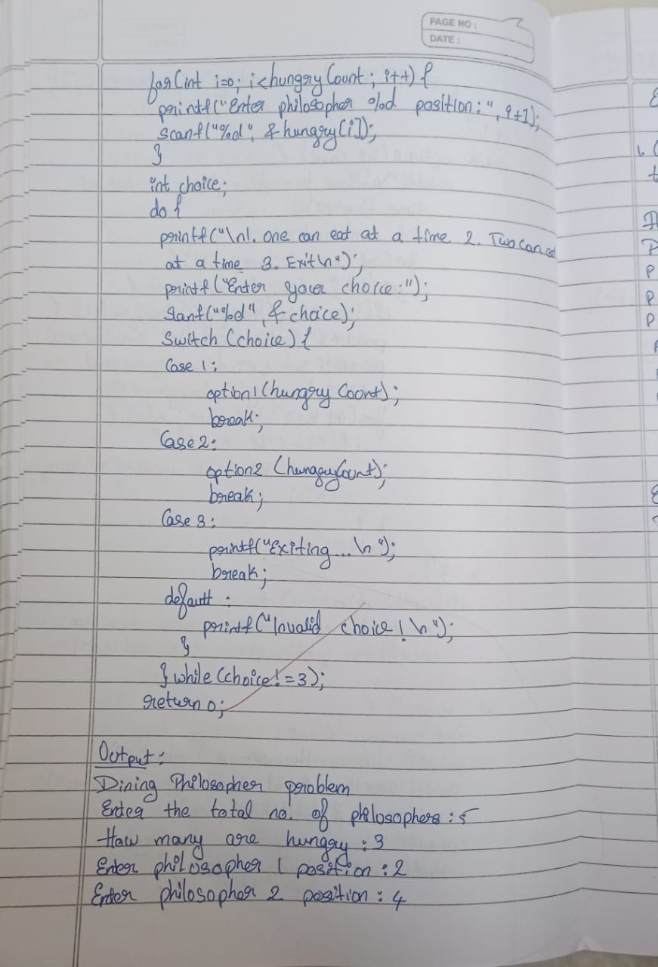

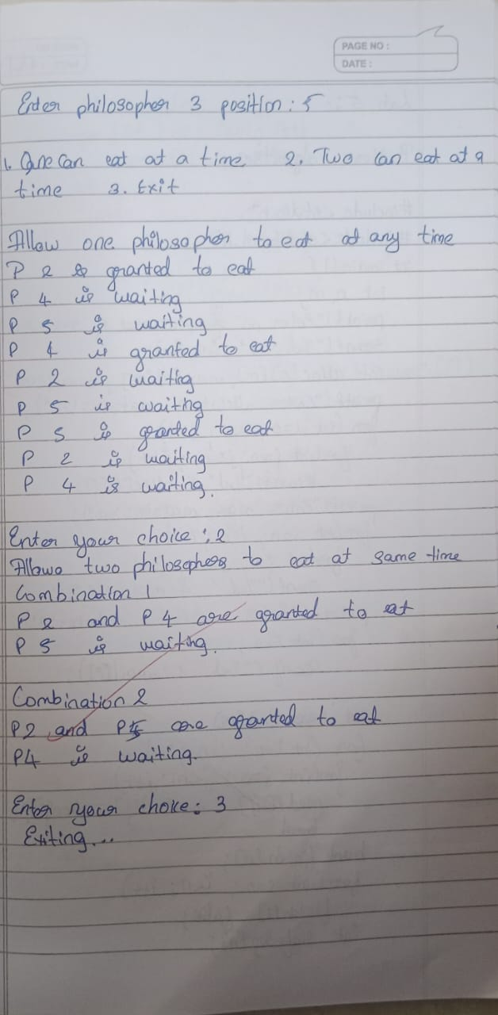

**Lab 5:**

**Write a C program to simulate Bankers algorithm for the purpose of deadlock**

**avoidance.**

#include <stdio.h>

#include <stdbool.h>

int main() {

int n, m;

printf("Enter number of processes and resources:\n");

scanf("%d %d", &n, &m);

int alloc[n][m], max[n][m], avail[m];

printf("Enter allocation matrix:\n");

for (int i = 0; i < n; i++)

for (int j = 0; j < m; j++)

scanf("%d", &alloc[i][j]);

printf("Enter max matrix:\n");

for (int i = 0; i < n; i++)

for (int j = 0; j < m; j++)

scanf("%d", &max[i][j]);

printf("Enter available matrix:\n");

for (int i = 0; i < m; i++)

scanf("%d", &avail[i]);

int need[n][m];

for (int i = 0; i < n; i++)

for (int j = 0; j < m; j++)

need[i][j] = max[i][j] - alloc[i][j];

bool finish[n];

for (int i = 0; i < n; i++)

finish[i] = false;

int safeSeq[n];

int work[m];

for (int i = 0; i < m; i++)

work[i] = avail[i];

int count = 0;

while (count < n) {

bool found = false;

for (int p = 0; p < n; p++) {

if (!finish[p]) {

int j;

for (j = 0; j < m; j++)

if (need[p][j] > work[j])

break;

if (j == m) {

for (int k = 0; k < m; k++)

work[k] += alloc[p][k];

safeSeq[count++] = p;

finish[p] = true;

found = true;

}

}

}

if (!found) {

printf("System is not in a safe state.\n");

return 0;

}

}

printf("System is in safe state.\nSafe sequence is: ");

for (int i = 0; i < n; i++)

printf("P%d%s", safeSeq[i], (i == n - 1) ? "\n" : " -> ");

return 0;

}

**Output:**



1. **Write a C program to simulate deadlock detection**

#include <stdio.h>

#include <stdbool.h>

int main() {

int n, m;

printf("Enter number of processes and number of resources:\n");

scanf("%d %d", &n, &m);

int alloc[n][m], request[n][m], avail[m];

printf("Enter Allocation Matrix (%d x %d):\n", n, m);

for (int i = 0; i < n; i++)

for (int j = 0; j < m; j++)

scanf("%d", &alloc[i][j]);

printf("Enter Request Matrix (%d x %d):\n", n, m);

for (int i = 0; i < n; i++)

for (int j = 0; j < m; j++)

scanf("%d", &request[i][j]);

printf("Enter Available Resources (%d values):\n", m);

for (int i = 0; i < m; i++)

scanf("%d", &avail[i]);

int work[m];

for (int i = 0; i < m; i++)

work[i] = avail[i];

bool finish[n];

for (int i = 0; i < n; i++) {

bool hasAllocation = false;

for (int j = 0; j < m; j++) {

if (alloc[i][j] != 0) {

hasAllocation = true;

break;

}

}

finish[i] = hasAllocation ? false : true;

}

while (true) {

bool progress = false;

for (int i = 0; i < n; i++) {

if (!finish[i]) {

bool canGrant = true;

for (int j = 0; j < m; j++) {

if (request[i][j] > work[j]) {

canGrant = false;

break;

}

}

if (canGrant) {

for (int j = 0; j < m; j++)

work[j] += alloc[i][j];

finish[i] = true;

progress = true;

}

}

}

if (!progress)

break;

}

printf("\nDeadlock Detection Result:\n");

bool deadlock = false;

for (int i = 0; i < n; i++) {

if (!finish[i]) {

printf("Process P%d is DEADLOCKED\n", i);

deadlock = true;

} else {

printf("Process P%d is NOT deadlocked\n", i);

}

}

if (!deadlock)

printf("\nNo deadlock detected in the system.\n");

return 0;

}

**Output:**

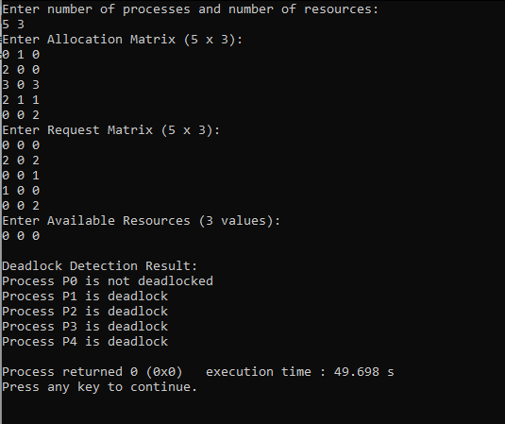

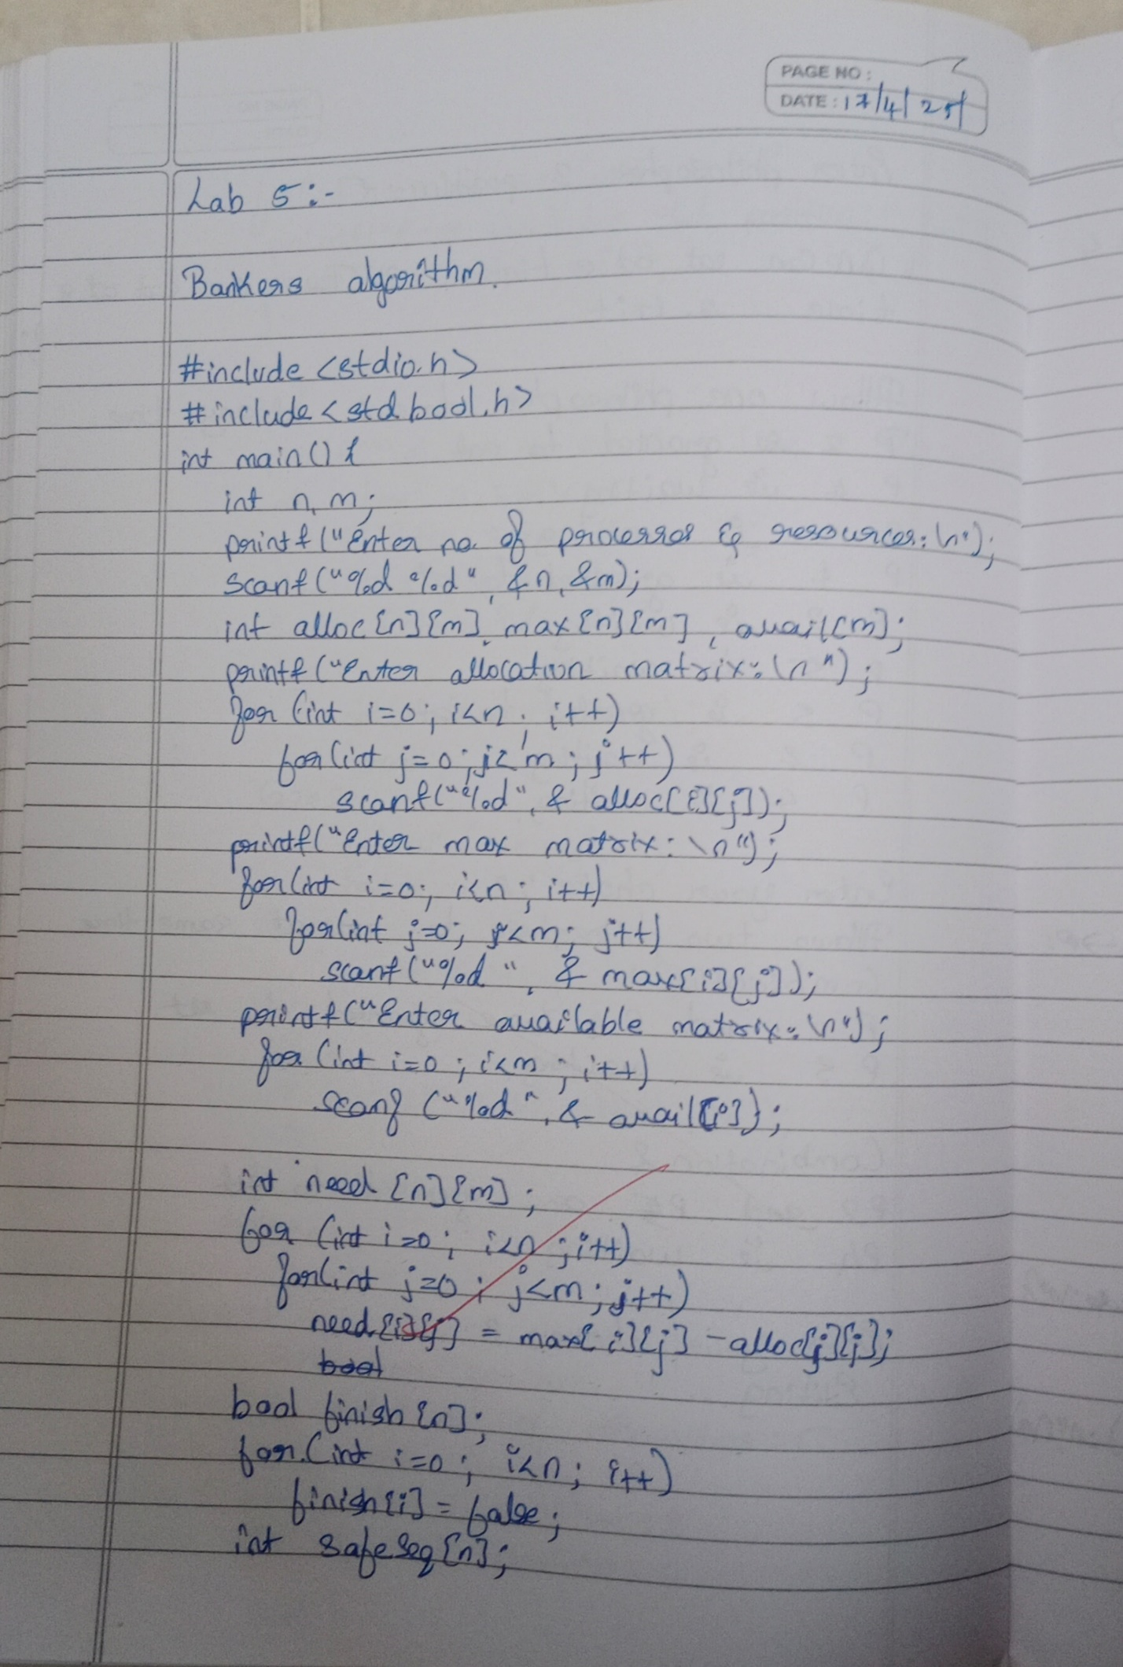

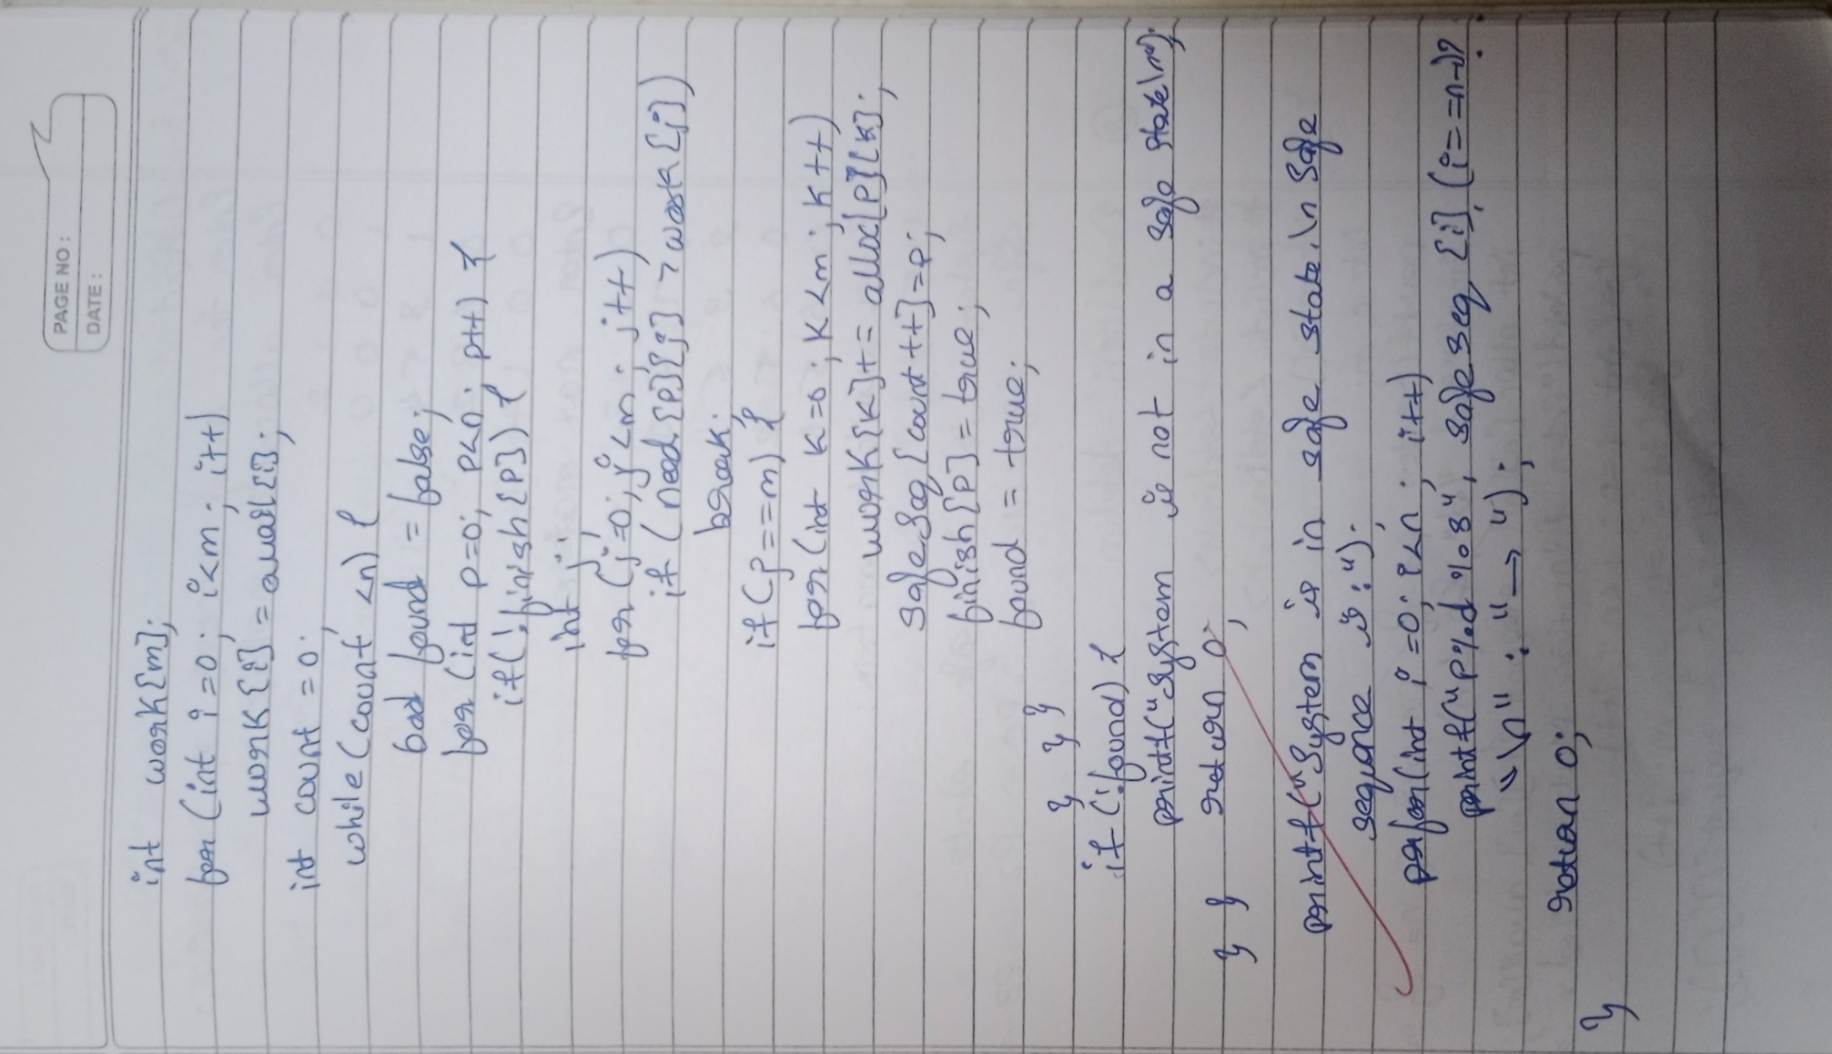

\

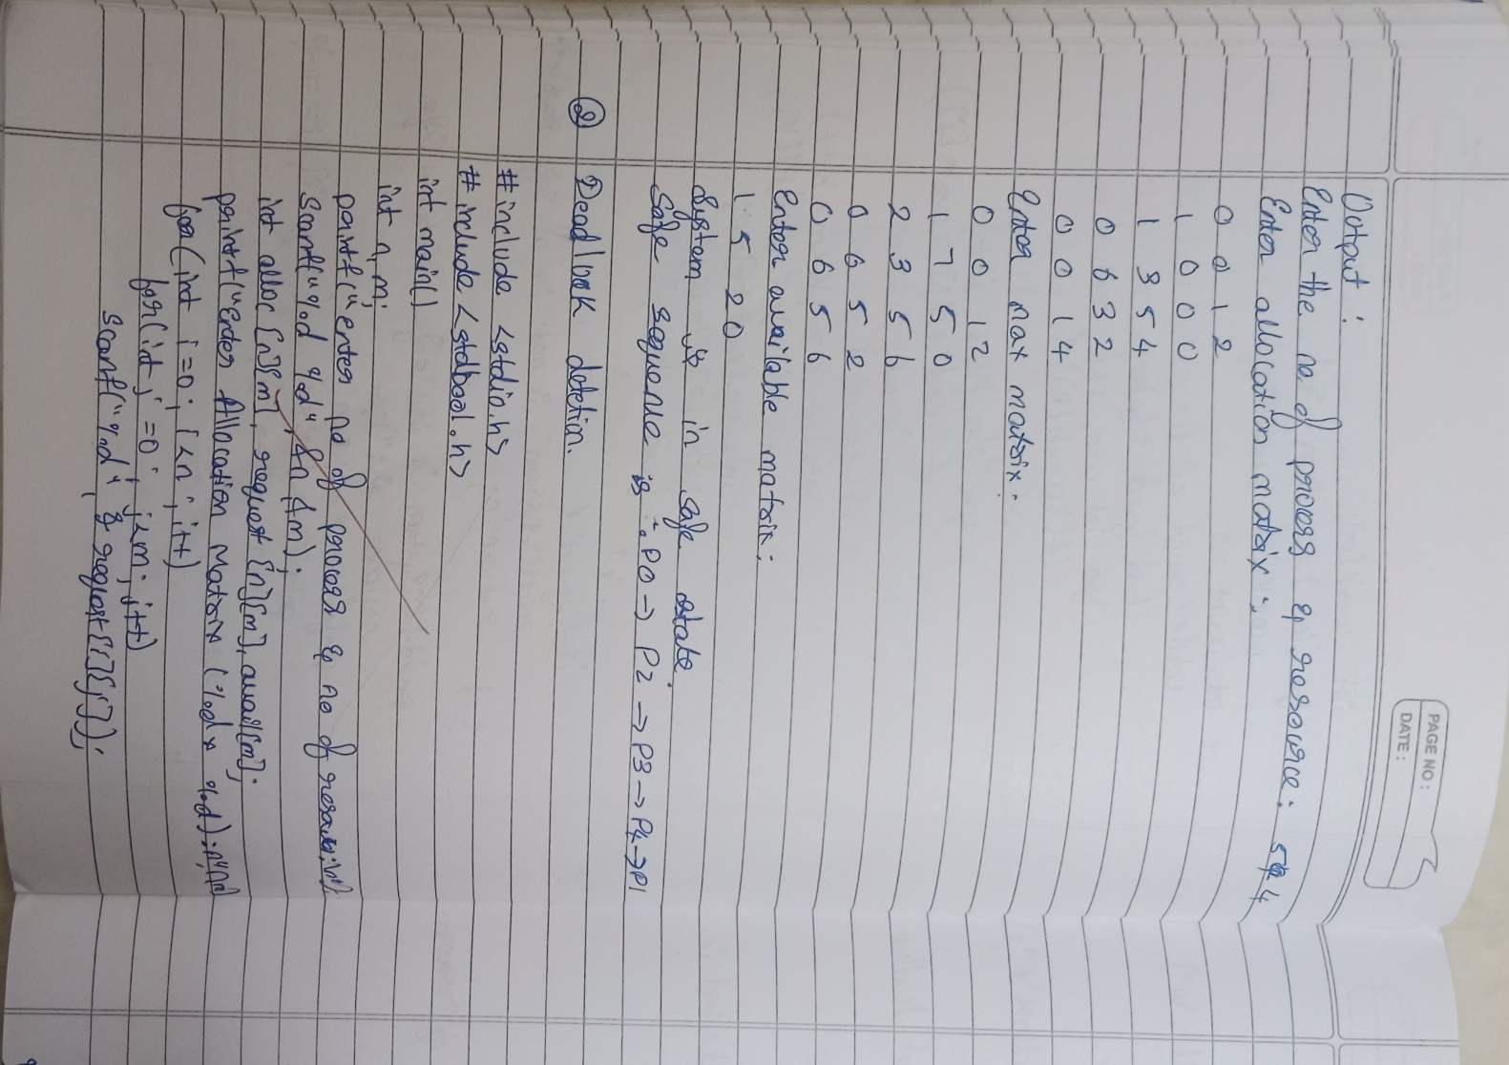

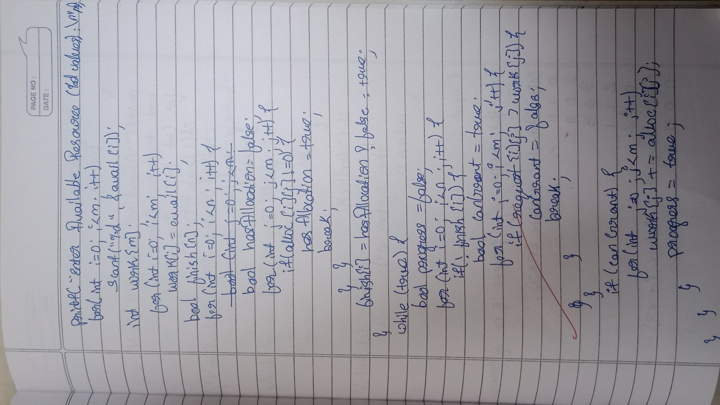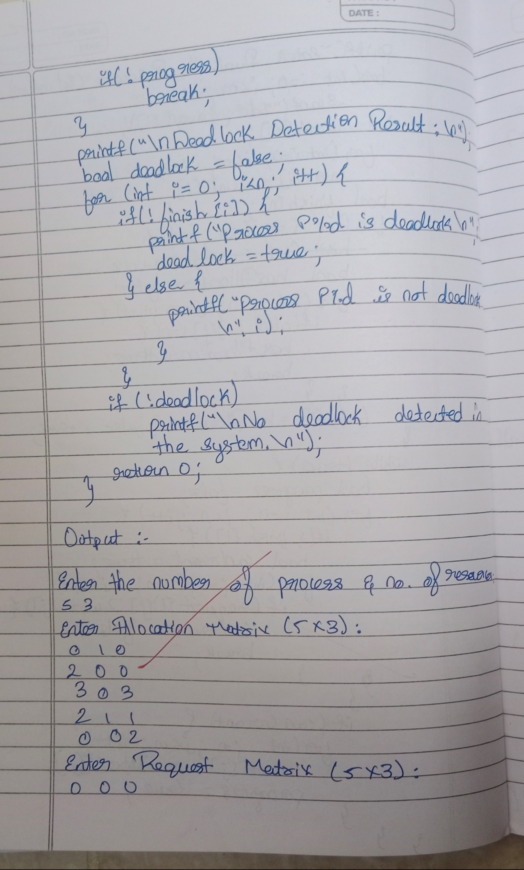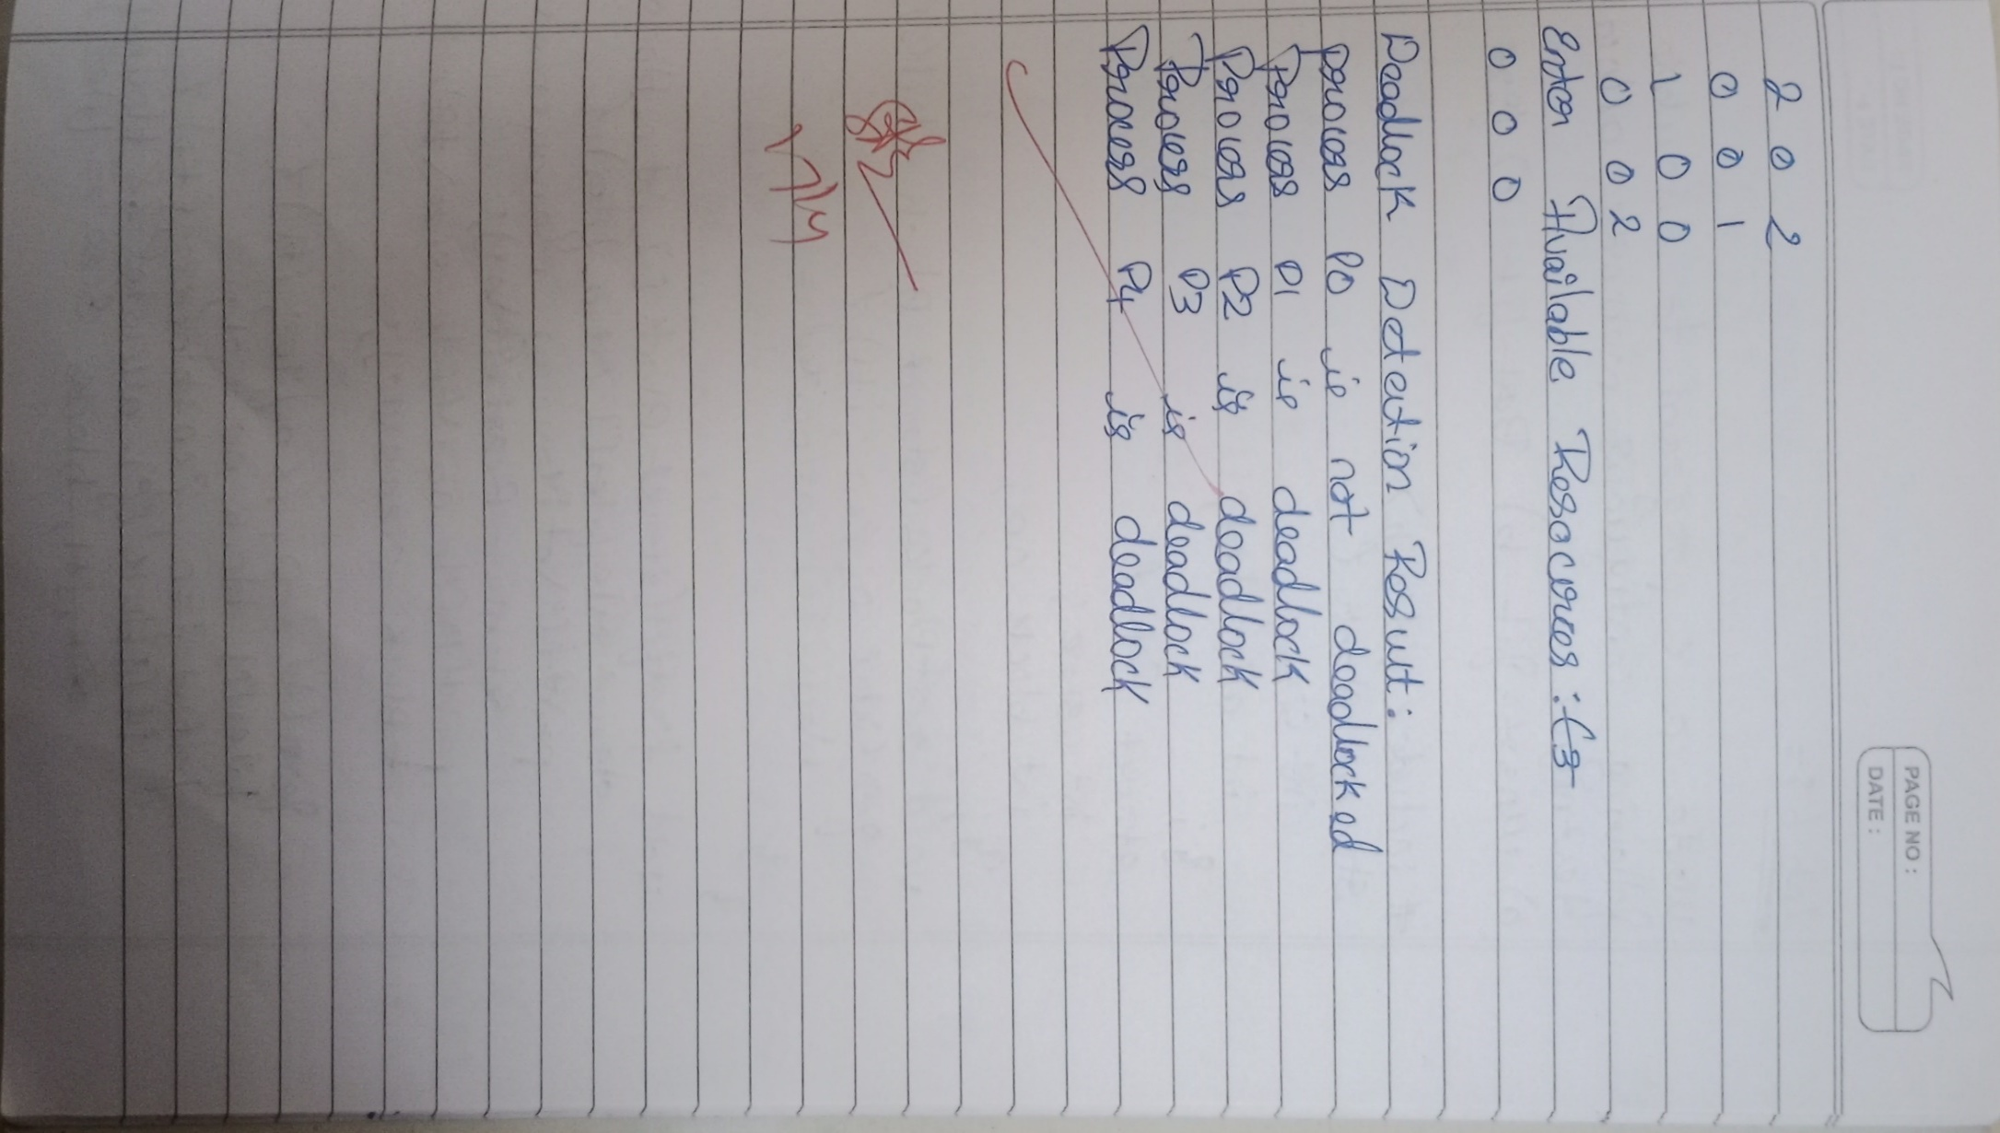

**Lab 6:**

**Write a C program to simulate the following contiguous memory allocation techniques**

**a) Worst-fit**

**b) Best-fit**

**c) First-fit**

#include <stdio.h>

struct Block {

int size;

int allocated;

};

struct File {

int size;

int block_no;

};

void resetBlocks(struct Block blocks[], int n) {

for (int i = 0; i < n; i++) {

blocks[i].allocated = 0;

}

}

void firstFit(struct Block blocks[], int n_blocks, struct File files[], int n_files) {

printf("\n\tMemory Management Scheme – First Fit\n");

printf("File_no:\tFile_size\tBlock_no:\tBlock_size:\n");

for (int i = 0; i < n_files; i++) {

files[i].block_no = -1;

for (int j = 0; j < n_blocks; j++) {

if (!blocks[j].allocated && blocks[j].size >= files[i].size) {

files[i].block_no = j + 1;

blocks[j].allocated = 1;

printf("%d\t\t%d\t\t%d\t\t%d\n", i + 1, files[i].size, j + 1, blocks[j].size);

break;

}

}

if (files[i].block_no == -1) {

printf("%d\t\t%d\t\t_\t\t_\n", i + 1, files[i].size);

}

}

}

void bestFit(struct Block blocks[], int n_blocks, struct File files[], int n_files) {

printf("\n\tMemory Management Scheme – Best Fit\n");

printf("File_no:\tFile_size\tBlock_no:\tBlock_size:\n");

for (int i = 0; i < n_files; i++) {

int bestIdx = -1;

for (int j = 0; j < n_blocks; j++) {

if (!blocks[j].allocated && blocks[j].size >= files[i].size) {

if (bestIdx == -1 || blocks[j].size < blocks[bestIdx].size) {

bestIdx = j;

}

}

}

if (bestIdx != -1) {

blocks[bestIdx].allocated = 1;

files[i].block_no = bestIdx + 1;

printf("%d\t\t%d\t\t%d\t\t%d\n", i + 1, files[i].size, bestIdx + 1, blocks[bestIdx].size);

} else {

printf("%d\t\t%d\t\t_\t\t_\n", i + 1, files[i].size);

}

}

}

void worstFit(struct Block blocks[], int n_blocks, struct File files[], int n_files) {

printf("\n\tMemory Management Scheme – Worst Fit\n");

printf("File_no:\tFile_size\tBlock_no:\tBlock_size:\n");

for (int i = 0; i < n_files; i++) {

int worstIdx = -1;

for (int j = 0; j < n_blocks; j++) {

if (!blocks[j].allocated && blocks[j].size >= files[i].size) {

if (worstIdx == -1 || blocks[j].size > blocks[worstIdx].size) {

worstIdx = j;

}

}

}

if (worstIdx != -1) {

blocks[worstIdx].allocated = 1;

files[i].block_no = worstIdx + 1;

printf("%d\t\t%d\t\t%d\t\t%d\n", i + 1, files[i].size, worstIdx + 1, blocks[worstIdx].size);

} else {

printf("%d\t\t%d\t\t_\t\t_\n", i + 1, files[i].size);

}

}

}

int main() {

int n_blocks, n_files, choice;

printf("Memory Management Scheme\n");

printf("Enter the number of blocks: ");

scanf("%d", &n_blocks);

printf("Enter the number of files: ");

scanf("%d", &n_files);

struct Block blocks[n_blocks];

struct File files[n_files];

printf("\nEnter the size of the blocks:\n");

for (int i = 0; i < n_blocks; i++) {

printf("Block %d: ", i + 1);

scanf("%d", &blocks[i].size);

blocks[i].allocated = 0;

}

printf("Enter the size of the files:\n");

for (int i = 0; i < n_files; i++) {

printf("File %d: ", i + 1);

scanf("%d", &files[i].size);

}

do {

printf("\n1. First Fit\n2. Best Fit\n3. Worst Fit\n4. Exit\n");

printf("Enter your choice: ");

scanf("%d", &choice);

resetBlocks(blocks, n_blocks); // Reset block allocation before each strategy

switch (choice) {

case 1:

firstFit(blocks, n_blocks, files, n_files);

break;

case 2:

bestFit(blocks, n_blocks, files, n_files);

break;

case 3:

worstFit(blocks, n_blocks, files, n_files);

break;

case 4:

printf("\nExiting...\n");

break;

default:

printf("Invalid choice.\n");

}

} while (choice != 4);

return 0;

}

**Output:**

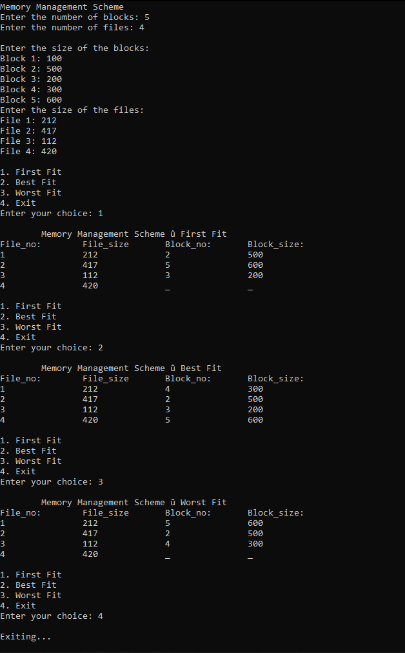

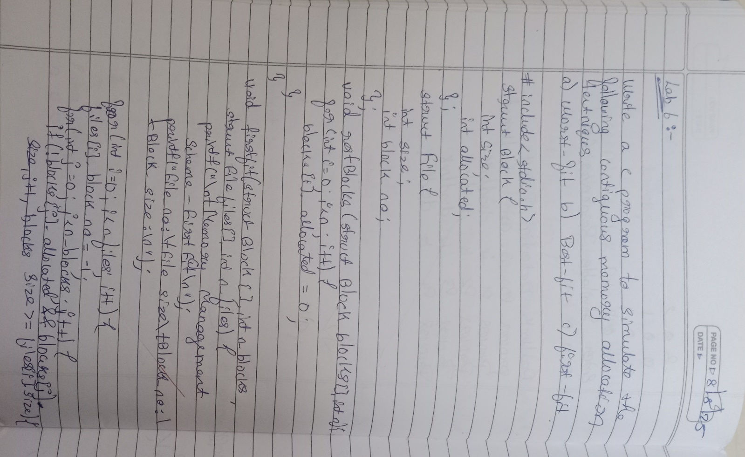

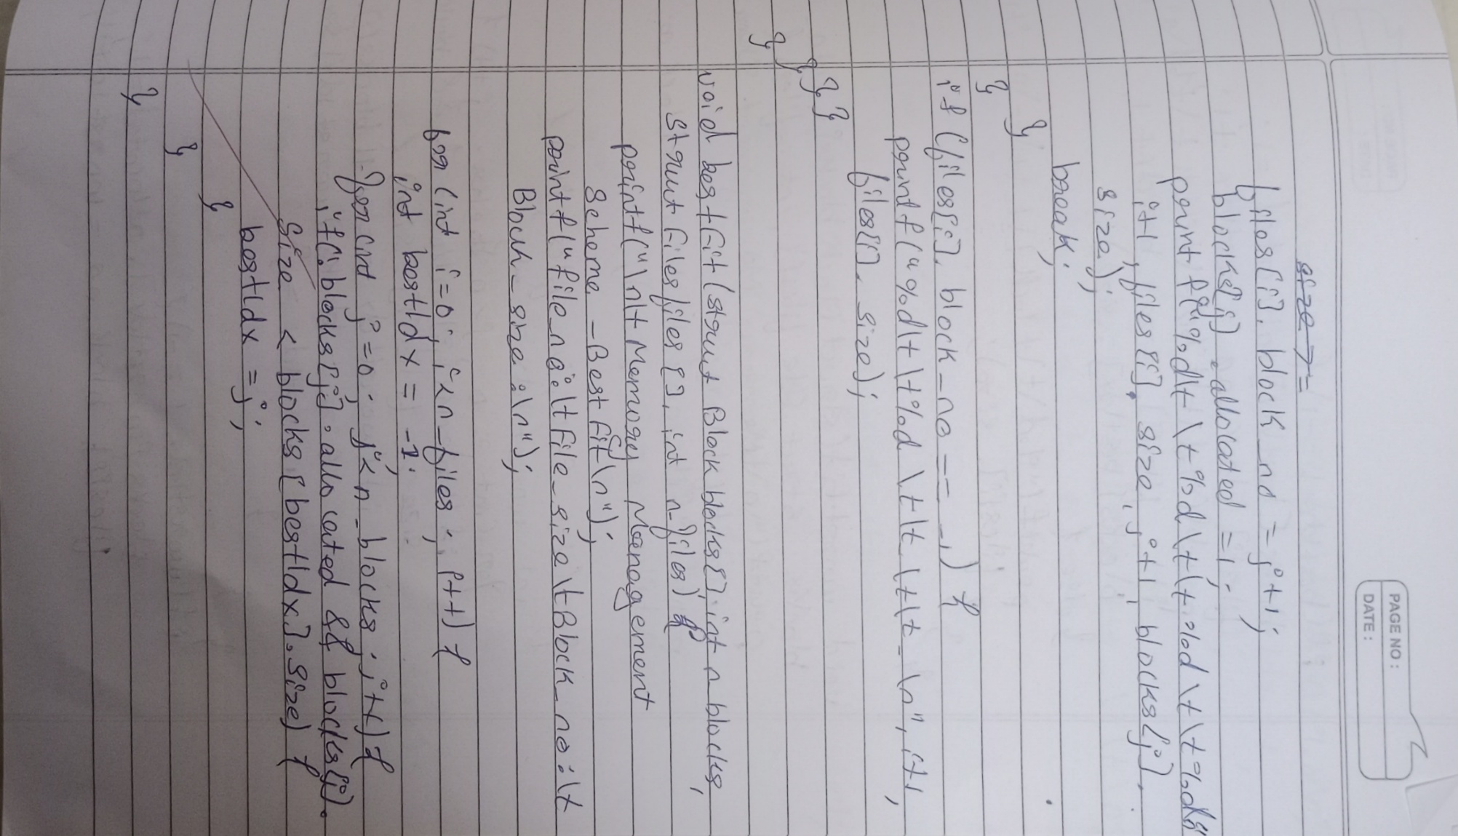

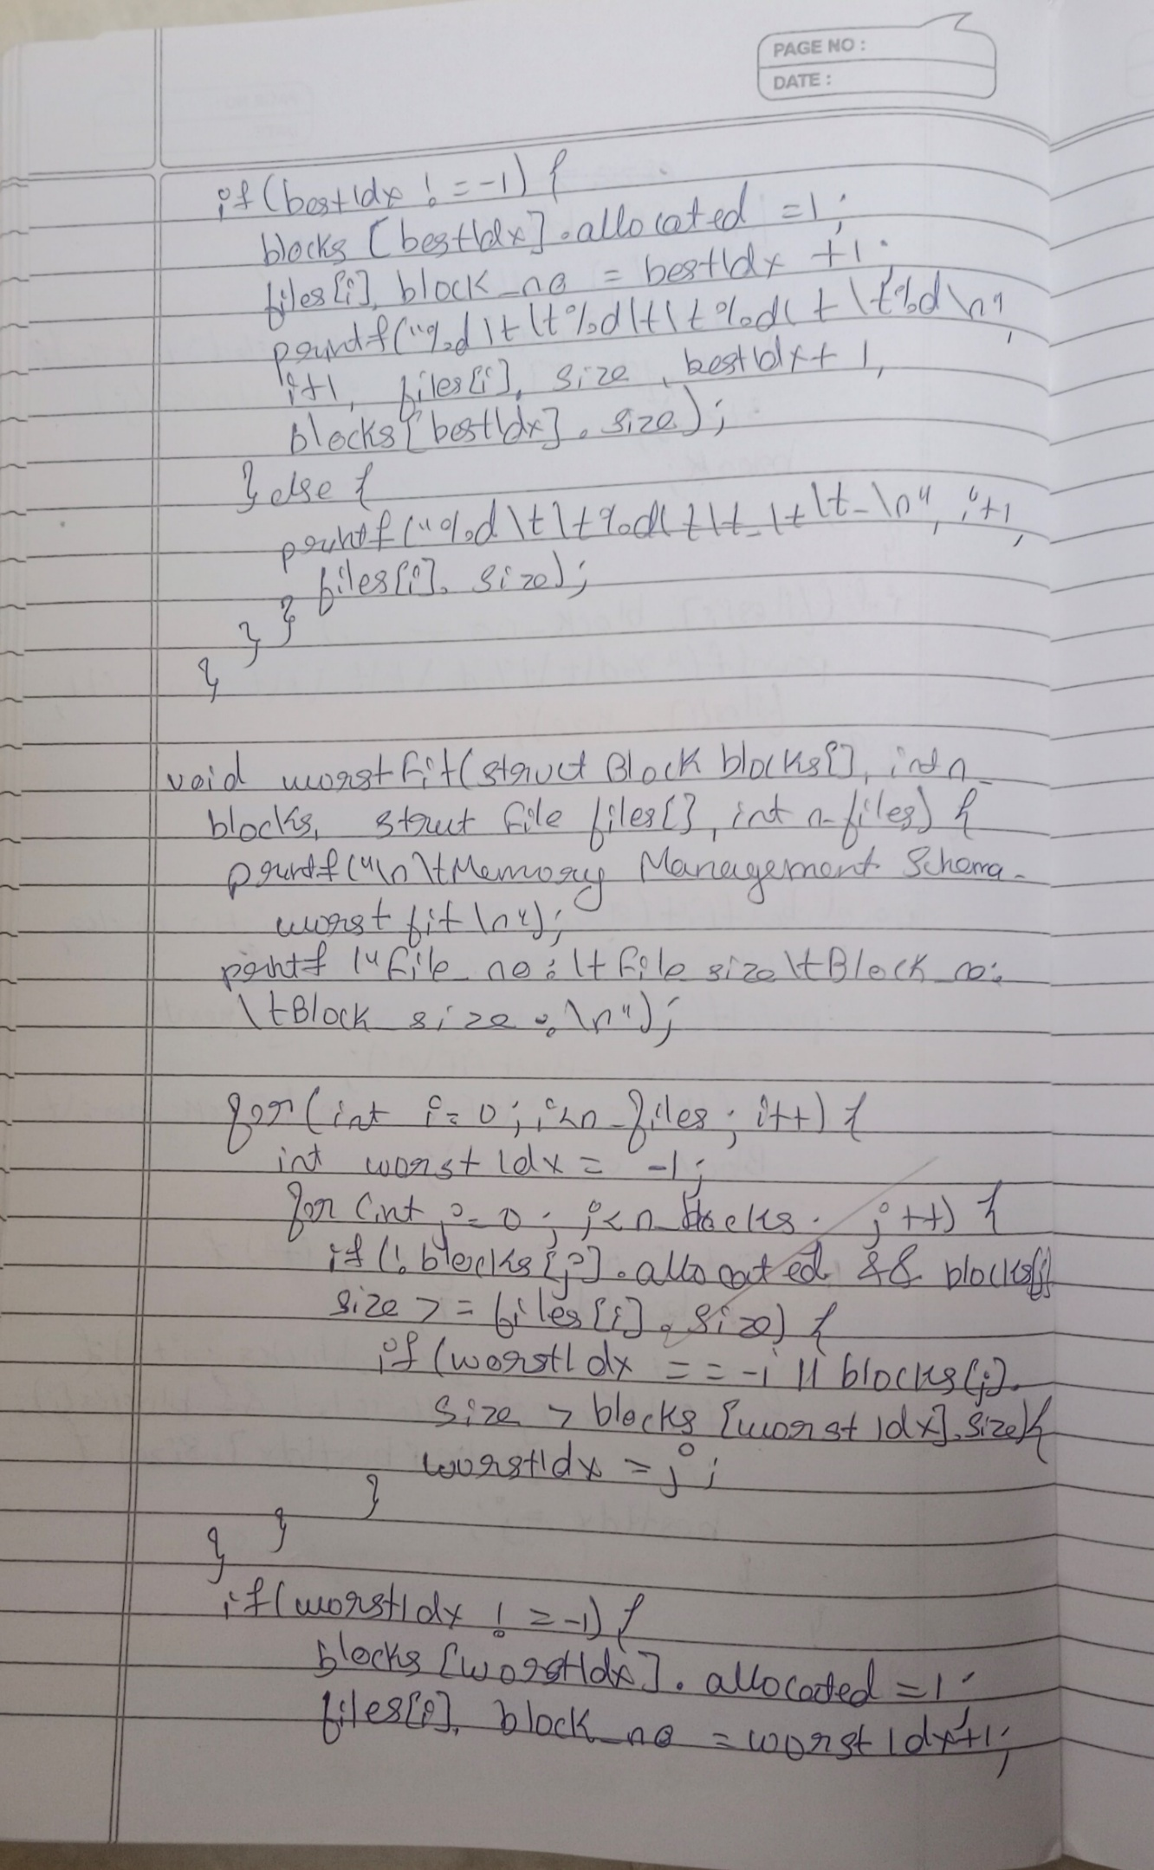

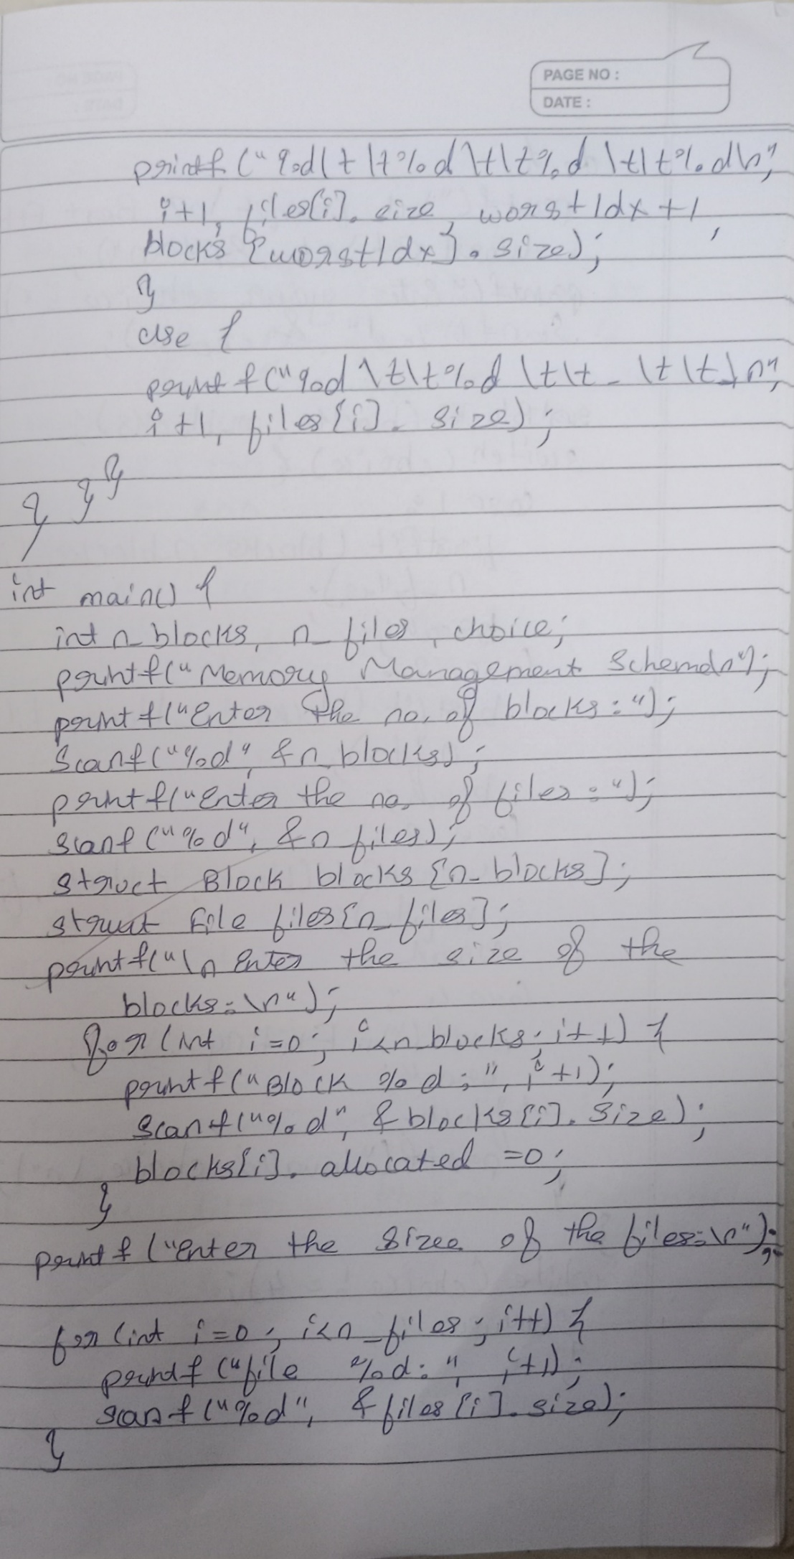

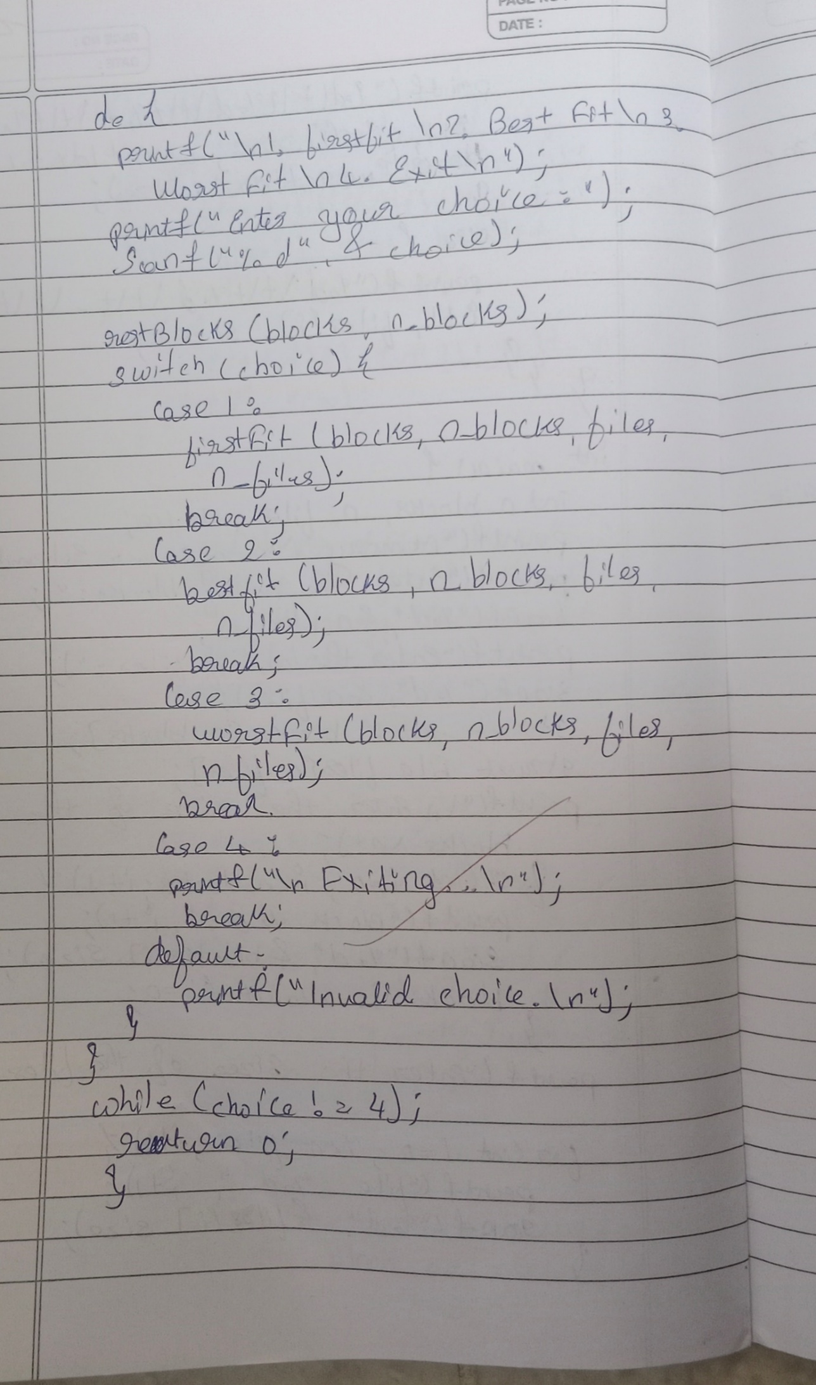

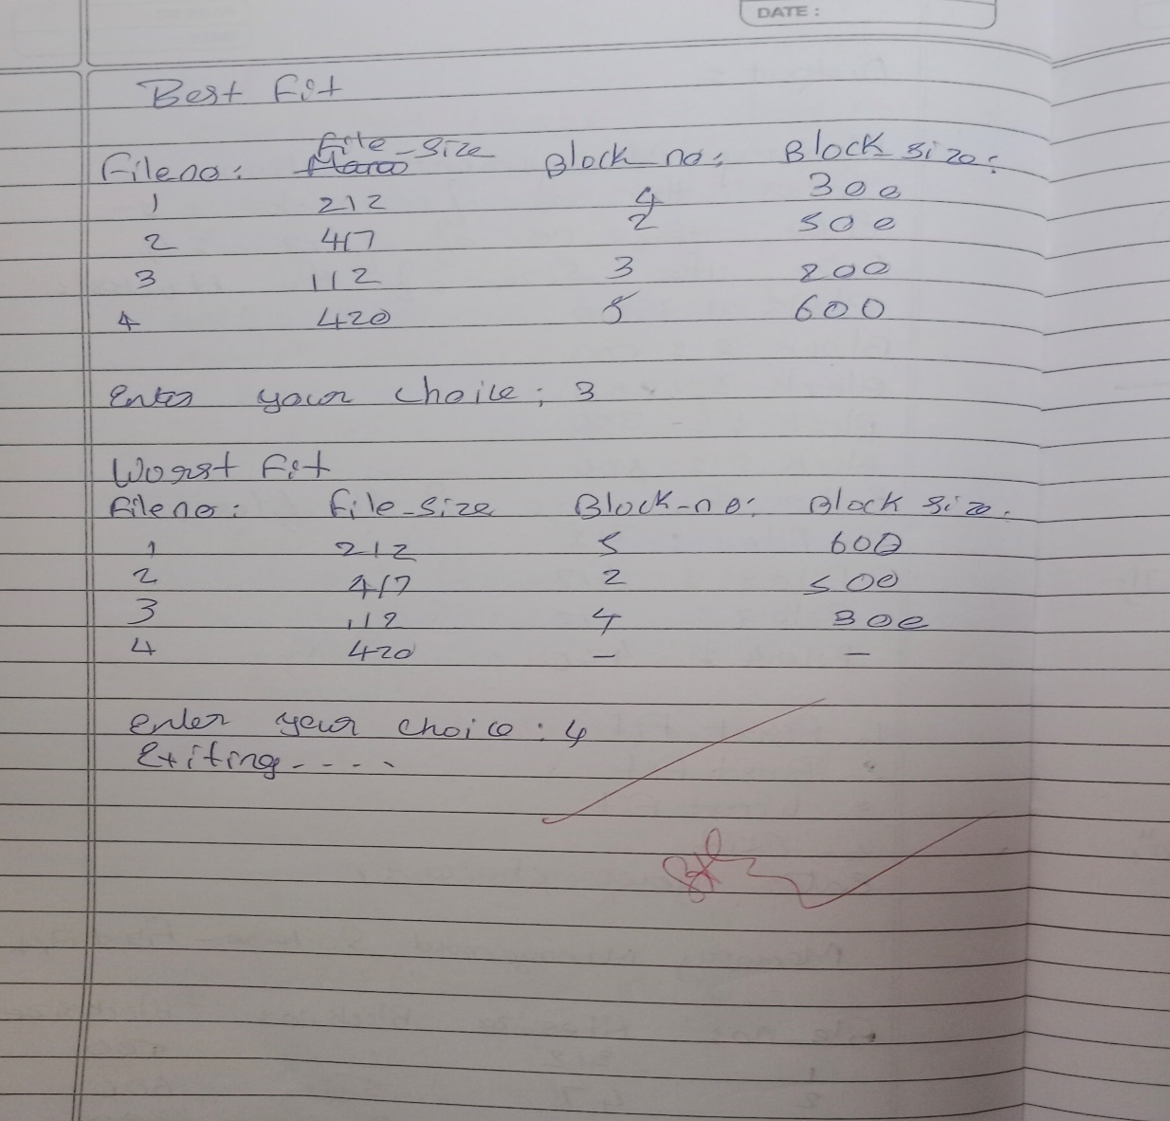

**Lab 7:**

**Write a C program to simulate page replacement algorithms**

**a)FIFO**

#include <stdio.h>  
  
int main() {  
    int frames, pages[50], n, frame[10], time[10];  
    int i, j, k, avail, count = 0, current_time = 0, pos, lru_time;  
  
    printf("Enter number of pages: ");  
    scanf("%d", &n);  
  
    printf("Enter the page reference string:\n");  
    for(i = 0; i < n; i++)  
        scanf("%d", &pages[i]);  
  
    printf("Enter number of frames: ");  
    scanf("%d", &frames);  
  
    for(i = 0; i < frames; i++) {  
        frame[i] = -1;  
        time[i] = -1;  
    }  
  
    printf("\nPage\tFrames\t\tPage Fault\n");  
  
    for(i = 0; i < n; i++) {  
        avail = 0;  
        current_time++;  
  
        for(j = 0; j < frames; j++) {  
            if(frame[j] == pages[i]) {  
                avail = 1;  
                time[j] = current_time;  
                break;  
            }  
        }  
  
        if(avail == 0) {  
            pos = 0;  
            lru_time = time[0];  
  
            for(j = 1; j < frames; j++) {  
                if(time[j] < lru_time) {  
                    lru_time = time[j];  
                    pos = j;  
                }  
            }  
  
            frame[pos] = pages[i];  
            time[pos] = current_time;  
            count++;  
  
            printf("%d\t", pages[i]);  
            for(k = 0; k < frames; k++) {  
                if(frame[k] != -1)  
                    printf("%d ", frame[k]);  
                else  
                    printf("- ");  
            }  
            printf("\tYes\n");  
        } else {  
            printf("%d\t", pages[i]);  
            for(k = 0; k < frames; k++) {  
                if(frame[k] != -1)  
                    printf("%d ", frame[k]);  
                else  
                    printf("- ");  
            }  
            printf("\tNo\n");  
        }  
    }  
  
    printf("\nTotal Page Faults = %d\n", count);  
    return 0;  
}

**Output:**

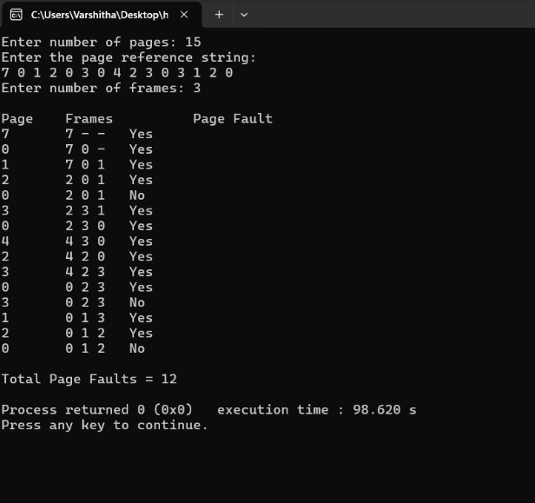

1. **LRU**

#include <stdio.h>  
  
int main() {  
    int n, frames, i, j, k, faults = 0;  
    printf("Enter number of pages: ");  
    scanf("%d", &n);  
    int pages[n];  
    printf("Enter the reference string: ");  
    for(i = 0; i < n; i++)  
        scanf("%d", &pages[i]);  
  
    printf("Enter number of frames: ");  
    scanf("%d", &frames);  
  
    int frame_arr[frames];  
    int time[frames]; // To track the usage time  
    for(i = 0; i < frames; i++) {  
        frame_arr[i] = -1;  
        time[i] = 0;  
    }  
  
    int counter = 0;  
    for(i = 0; i < n; i++) {  
        int flag = 0;  
        for(j = 0; j < frames; j++) {  
            if(frame_arr[j] == pages[i]) {  
                flag = 1;  
                counter++;  
                time[j] = counter; // Update the usage time  
                break;  
            }  
        }  
  
        if(flag == 0) { // Page fault  
            faults++;  
            int min_time = time[0], min_pos = 0;  
            for(k = 1; k < frames; k++) {  
                if(time[k] < min_time) {  
                    min_time = time[k];  
                    min_pos = k;  
                }  
            }  
            frame_arr[min_pos] = pages[i]; // Replace the least recently used  
            counter++;  
            time[min_pos] = counter; // Update the usage time for the new page  
        }  
  
        printf("Frames after accessing %d: ", pages[i]);  
        for(j = 0; j < frames; j++) {  
            if(frame_arr[j] == -1)  
                printf("- ");  
            else  
                printf("%d ", frame_arr[j]);  
        }  
        printf("\n");  
    }  
  
    printf("Total page faults: %d\n", faults);  
    int Hits = n-faults;  
    printf("Total page Hits: %d\n",Hits);  
    return 0;  
}

**Output:**

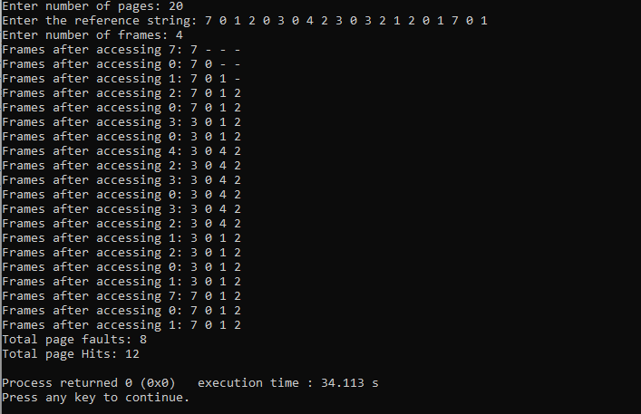

**c) Optimal**

#include <stdio.h>

int main() {

    int n, frames, i, j, k, faults = 0;

    printf("Enter number of pages: ");

    scanf("%d", &n);

    int pages[n];

    printf("Enter the reference string: ");

    for(i = 0; i < n; i++)

        scanf("%d", &pages[i]);

    printf("Enter number of frames: ");

    scanf("%d", &frames);

    int frame_arr[frames];

    for(i = 0; i < frames; i++)

        frame_arr[i] = -1;

    for(i = 0; i < n; i++) {

        int flag = 0;

        for(j = 0; j < frames; j++) {

            if(frame_arr[j] == pages[i]) {

                flag = 1;

                break;

            }

        }

        if(flag == 0) {

            faults++;

            int pos = -1;

            for(j = 0; j < frames; j++) {

                if(frame_arr[j] == -1) {

                    pos = j;

                    break;

                }

            }

            if(pos == -1) {

                int farthest = i, replace_index = 0;

                for(j = 0; j < frames; j++) {

                    int found = 0;

                    for(k = i + 1; k < n; k++) {

                        if(frame_arr[j] == pages[k]) {

                            if(k > farthest) {

                                farthest = k;

                                replace_index = j;

                            }

                            found = 1;

                            break;

                        }

                    }

                    if(!found) {

                        replace_index = j;

                        break;

                    }

                }

                pos = replace_index;

            }

            frame_arr[pos] = pages[i];

        }

        printf("%d: ", pages[i]);

        for(j = 0; j < frames; j++) {

            if(frame_arr[j] == -1)

                printf("_ ");

            else

                printf("%d ", frame_arr[j]);

        }

        printf("\n");

    }

    printf("Total page faults: %d\n", faults);

    int Hits = n-faults;

    printf("Total page Hits: %d\n",Hits);

    return 0;

}

**Output:**

**.**

